We are observing:______________________________

Location: ___________________________________ Date/Time: _____________________

Weather (circle one): 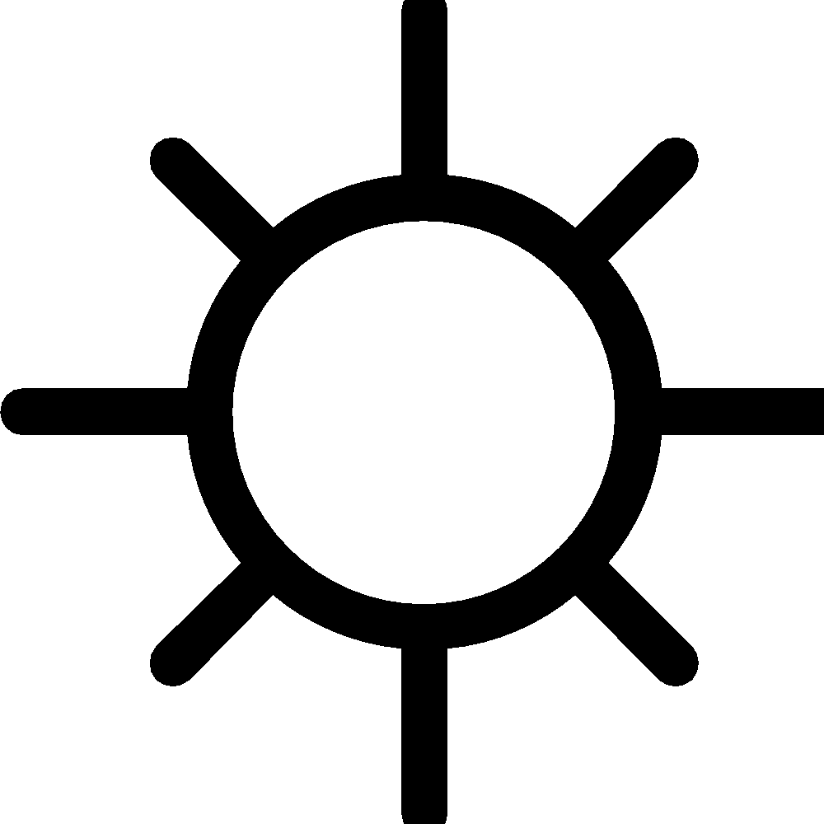 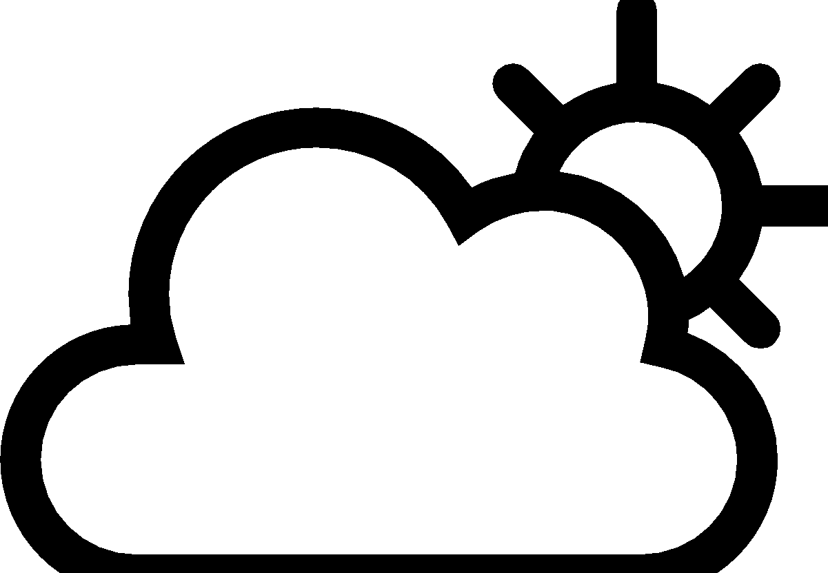 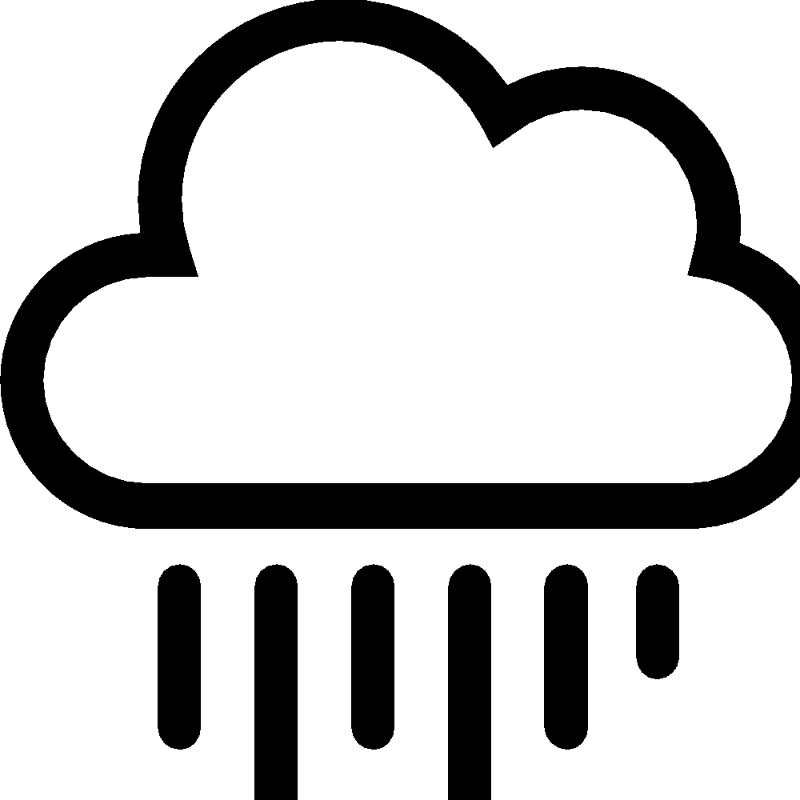 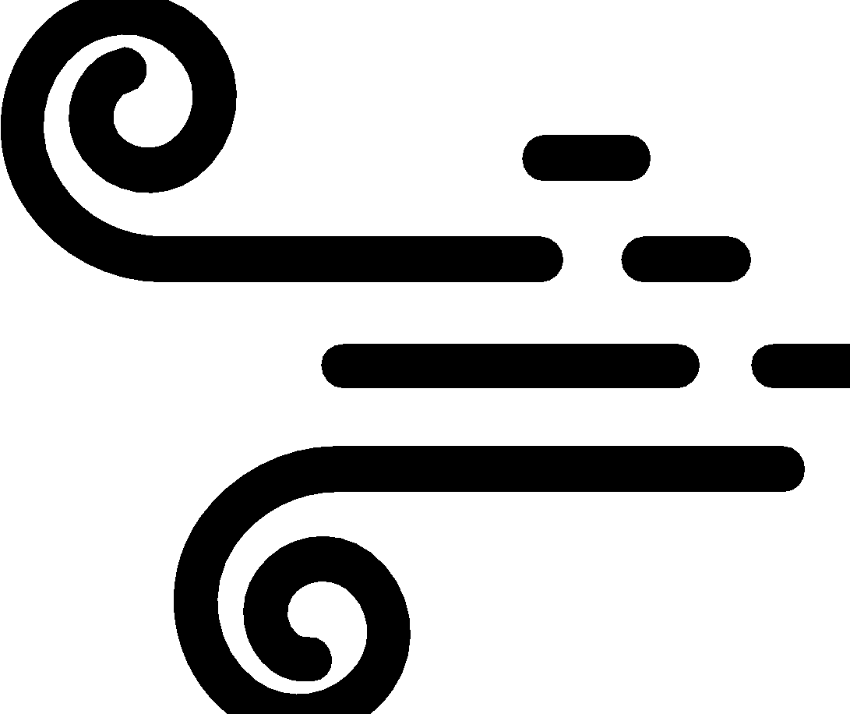 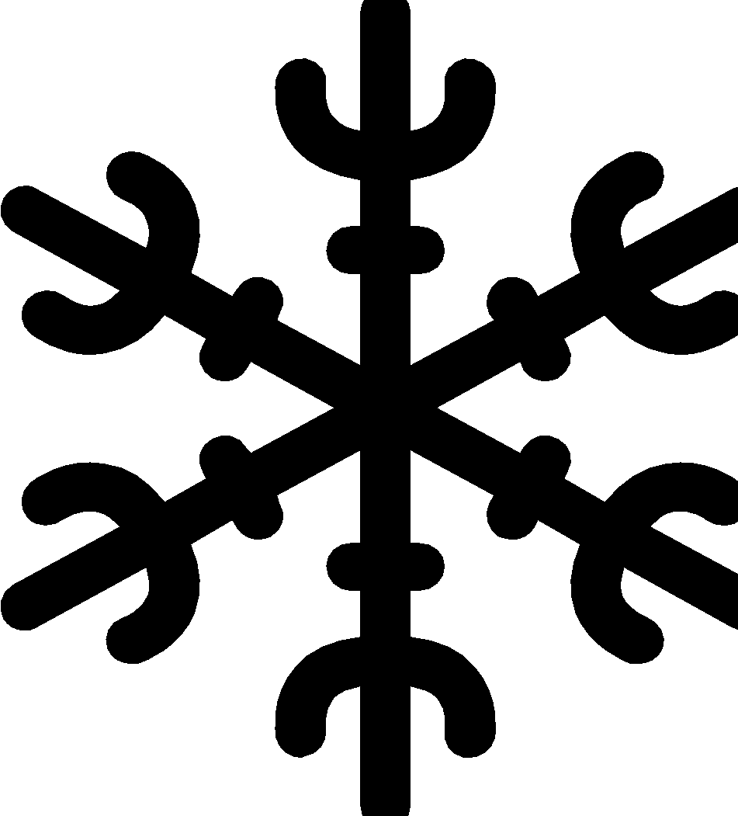 Temperature (hot, warm, cool, cold): _____________
Draw what you observe here, including relationships between animals, plants, weather, soil, etc.

↑above

around
← →

↓ below
We Wonder…

What was something that surprised you on your observation walk?

Has anything changed since the last time you did an observation walk? If so, why do you think this was so?

How do you think the weather and season today influenced what you observed? Do you think anything else influenced what you observed today?

