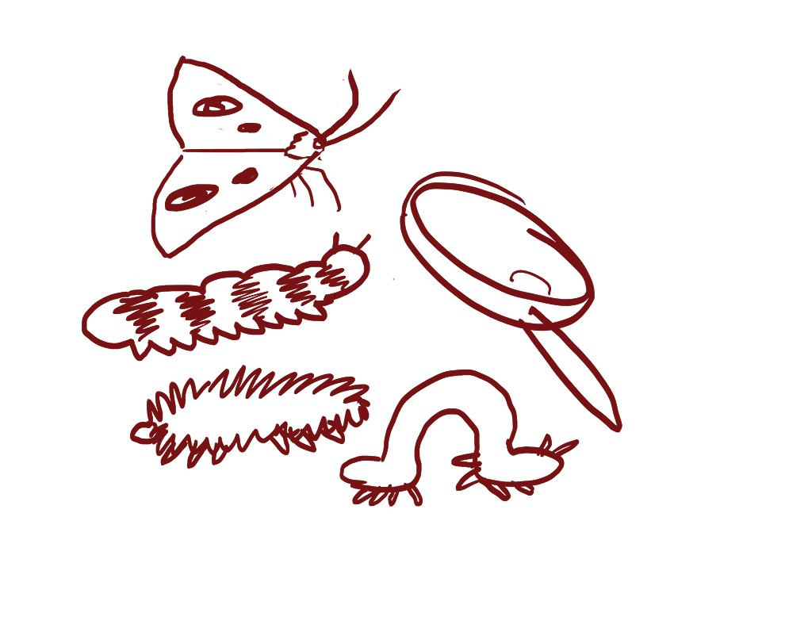
LE 3.A Taking A Focused Walk Together: Species, Kinds and Behaviors
Observing species and their behaviors is important for understanding components of socio-ecological systems. Some questions to keep in mind as you walk with your family are:

- What plants are you noticing? Are there any patterns in growth?
- What signs of animals do you see? Where?
- What are you noticing about them? At what stage of life are they in?
- Who or what are these species in relation with? How can you tell?
- Where do you think the water is? Where is the sun? What do you notice about the ground you are walking on?

Draw or write down any signs of species, kinds and behaviors that you notice. | We noticed:  __________________________________  __________________________________  __________________________________  __________________________________  __________________________________  __________________________________  __________________________________  __________________________________  __________________________________  __________________________________  __________________________________
We wonder:

__________________________________

__________________________________

__________________________________

__________________________________

__________________________________

__________________________________

__________________________________

__________________________________

__________________________________

__________________________________

__________________________________

