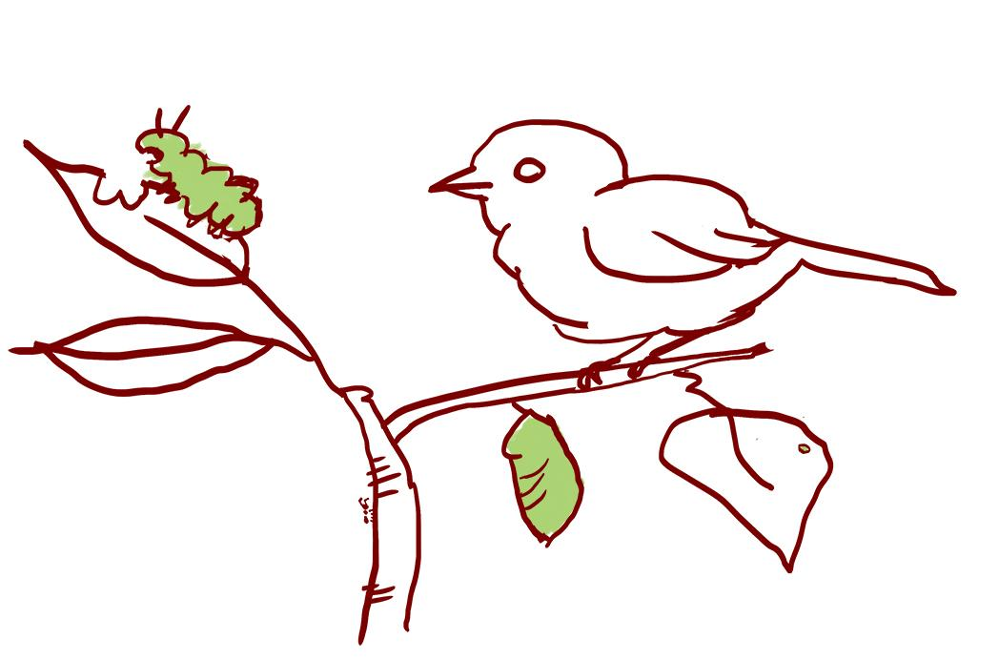
LE 3.B Taking A Focused Walk Together: Relationships
Learning to notice relationships in the natural world is important for understanding science concepts. The focus on connections among different members and parts of a system helps us understand the many ways in which everything is connected. Some questions to consider while you walk with your family:

- What kinds of relationships are you noticing? What does it remind you of?
- Who is in a relationship with whom? Who or what benefits from this relationship?
- Can you find a relationship that is not directly connected, but still part of the bigger system?

Draw or write down any signs of relationships that you notice. What do they make you wonder? | We noticed:  __________________________________  __________________________________  __________________________________  __________________________________  __________________________________  __________________________________  __________________________________  __________________________________  __________________________________  __________________________________  __________________________________  __________________________________
We wonder:

__________________________________

__________________________________

__________________________________

__________________________________

__________________________________

__________________________________

__________________________________

__________________________________

__________________________________

__________________________________

__________________________________

__________________________________

