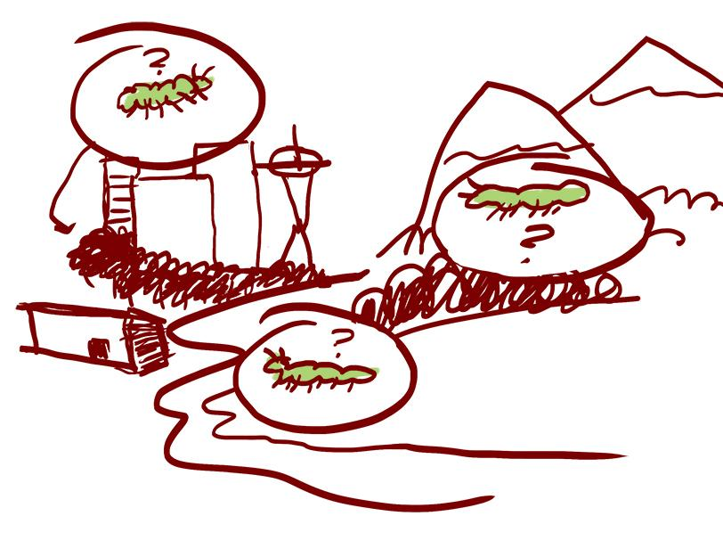
LE 3.C Taking A Focused Walk Together: Places Lands and Waters
Looking closely at the lands and waters around us is important for field-based science learning. Noticing the details of place allows for a deeper understanding about complex systems. Some questions to consider while you walk with your family:

- What is the shape of the land? Where do you see water? Who is gathering in what places?
- Look closely at the ground, what do you see? Look out at the horizon, what do you notice?
- How did this place come to be this way? Has it always been this way? Will it always be this way?

Draw or write down anything you notice about the places, lands and waters. What do they make you wonder? | We noticed:  __________________________________  __________________________________  __________________________________  __________________________________  __________________________________  __________________________________  __________________________________  __________________________________  __________________________________  __________________________________  __________________________________
We wonder:

__________________________________

__________________________________

__________________________________

__________________________________

__________________________________

__________________________________

__________________________________

__________________________________

__________________________________

__________________________________

__________________________________

__________________________________

