LE 3.D Taking A Focused Walk Together: Human Decision Making
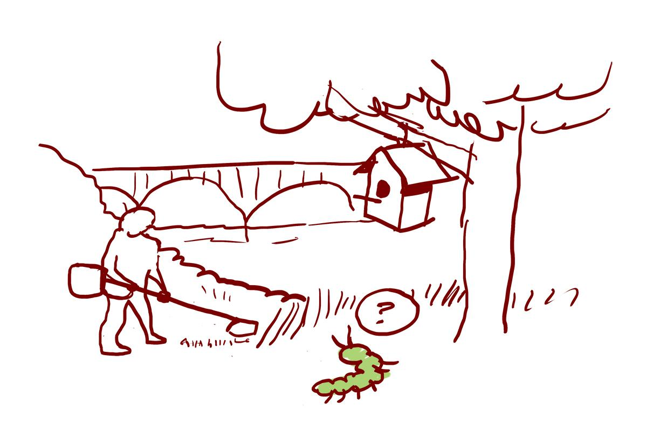
Humans have had, and will continue to have, important relationships that shape places and natural systems. Thinking about how and why humans interact with the natural world helps us to think deeper about possible futures. Some questions to consider while you walk with your family:

- Look for places where humans have touched the land. Why do you think these choices were made and how might they be impacting other species or kinds?
- Are these impacts helping, harming, or just neutral? What could be done differently?
- What kinds of choices did humans 1,000 years ago have to make? 100 years ago? 50 years ago?
- How will the decisions we make now impact the future? How do you know?
Draw or write down signs of human decision making. What do they make you wonder? | We noticed:  __________________________________  __________________________________  __________________________________  __________________________________  __________________________________  __________________________________  __________________________________  __________________________________  __________________________________  __________________________________  __________________________________  __________________________________
We wonder:

__________________________________

__________________________________

__________________________________

__________________________________

__________________________________

__________________________________

__________________________________

__________________________________

__________________________________

__________________________________

__________________________________

__________________________________

