LE. 3.E Taking A Focused Walk Together: Thinking Across Scales
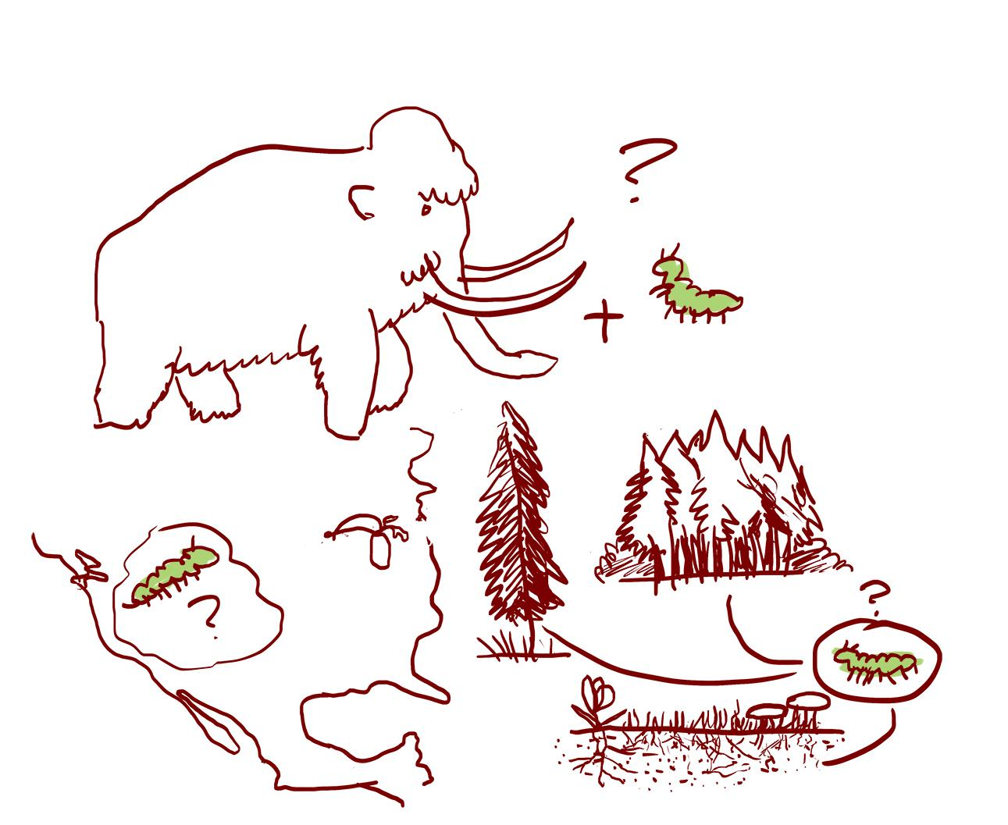
Thinking across scales while observing helps us to develop a deeper understanding of our socio-ecological systems. This includes considering different time and space scales, looking for signs of life cycles, energy cycles, water cycles, etc. Some questions to consider while you are walking with your family:
- What did this place look like before animals and humans? What will it look like in the future?
- What is life like for this tiny bug? What has that giant tree lived through?
- Where has this water been before it came here? Where will it go from here?
Draw or write down any signs you notice while thinking across scales What scales have you used to think with? What do your observations make you wonder? | We noticed:  __________________________________  __________________________________  __________________________________  __________________________________  __________________________________  __________________________________  __________________________________  __________________________________  __________________________________  __________________________________  __________________________________  __________________________________
We wonder:

__________________________________

__________________________________

__________________________________

__________________________________

__________________________________

__________________________________

__________________________________

__________________________________

__________________________________

__________________________________

__________________________________

__________________________________

