Pick a “Should We” Question, Explore It, and Model It

Part A: Pick a “Should We” Question

Look back at the “Should We” questions your family came up with in LE 5.C. Your first task is to pick a “Should We” question from that list to focus on, or your family might choose to come up with a new “Should We” question. The “Should We” question that you choose is important because you will be using it to guide the rest of your work. Here are some things to think about to help your family pick a “Should We” question:

- Your “Should We” question should be socio-ecological, meaning it should involve interlinked human and natural parts of systems.
  - “Should we try and identify the type of bird that visits our bird feeder?” is not the type of “Should We” question we are talking about. This is a yes/no question that no one needs to investigate to respond to.
  - “Should we remove or add more bird feeders to our backyard or neighborhood garden?” is the type of “Should We” question we are talking about. There is not a “right” answer and in order to make a sound decision, there are various investigations that would be helpful.
- Your “Should We” question should not have an obvious right answer. It is the type of question that your family can deliberate about.
- Your “Should We” question should be specific to your neighborhood (your yard, your apartment complex, your block).
- Your “Should We” question should be interesting and important to your family. You should be interested and excited to learn more about it.

Complete the chart on the next page. Recreate the chart on another page if you have more than two “Should We” questions that you want to consider. Once you’ve explored your “Should We” questions using the various criteria, identify the one “Should We” question that your family wants to use to guide the rest of your activities.

“Should We” Questions from LE 5.C (or new ones) | Which of these criteria does the “Should We” question meet? (Check all that apply!)
▢ involves relations between humans and more than humans (like animals, plants, rocks)
▢ involves multiple base relationships (like animal-plant, plant-plant; see LE 6.A)
▢ involves multiple socio-ecological timescales (see LE 1.C)
▢ we could collect data about this
▢ requires us to think about how our decisions would help create different social structures and futures
▢ no obvious right answer
▢ connected to your neighborhood
▢ interesting, important, and exciting to us
▢ involves relations between humans and more than humans (like animals, plants, rocks)
▢ involves multiple base relationships (like animal-plant, plant-plant; see LE 6.A)
▢ involves multiple socio-ecological timescales (see LE 1.C)
▢ we could collect data about this
▢ requires us to think about how our decisions would help create different social structures and futures
▢ no obvious right answer
▢ connected to your neighborhood
▢ interesting, important, and exciting to us
Which question did you end up choosing and why?

Part B: Explore Your “Should We” Question

Now that you’ve decided on a “Should We” question, make some notes about how your question involves the different aspects of socio-ecological systems below (you saw some/all of these dimensions if you went on any of the focused walks in LE 3). Use the prompts in the chart to help you think more deeply about your “Should We” question (every prompt might not apply).

5 Dimensions of Socio-Ecological Systems | Our Notes
Species, Kinds, and Behaviors

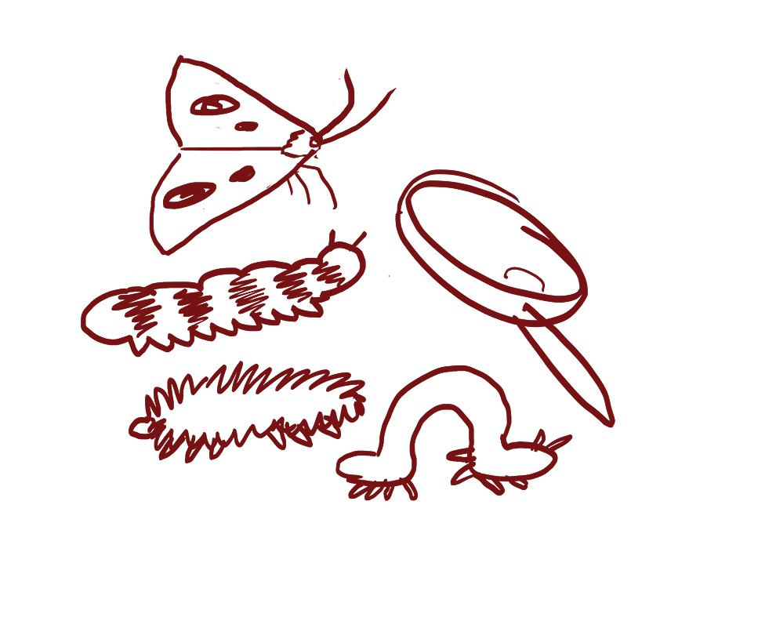
- What species (plants and animals, including humans) and kinds (things like water, rocks, the sun) are involved in your “Should We” question?
  - Consider the different time scales in LE 1.C. Would the same species and kinds you identified show up in all the various time scales or might there be other species and kinds present? Is that important for your “Should We” question, and if so, how?
- Describe any plant and/or animal (including human) behavior that is involved in your “Should We” question.
- What species and kinds have power over others? How does that power play out? Why might that be important to understand given your “Should We” question?

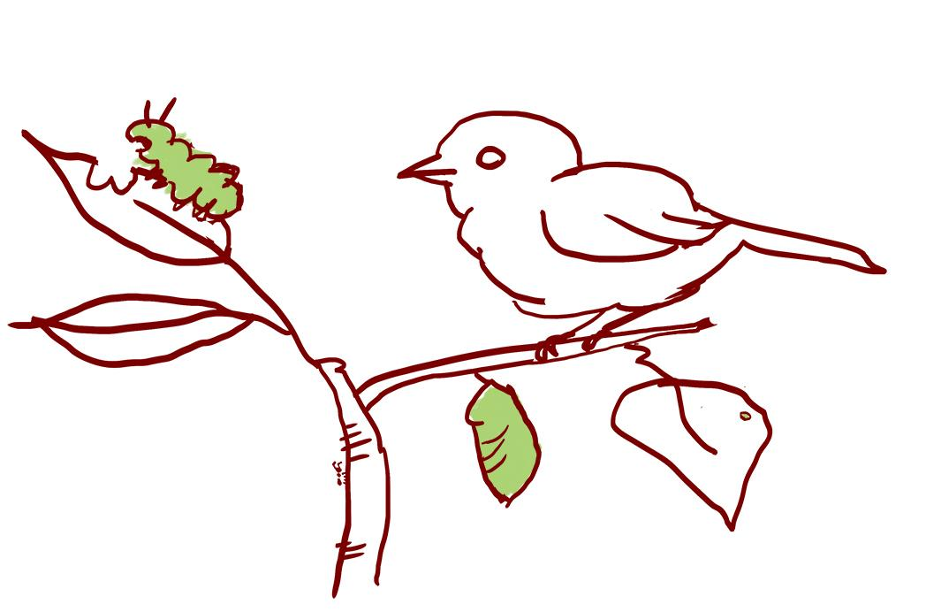
Relationships

- What relationships between species, kinds, places, lands, and/or waters are involved in your “Should We” question?
- Who benefits from these relationships? Who might not benefit? Why?
- If you consider the different time scales in LE 1.C, how might the relationships you identified stay the same or change across time?
Places, Lands, and Waters
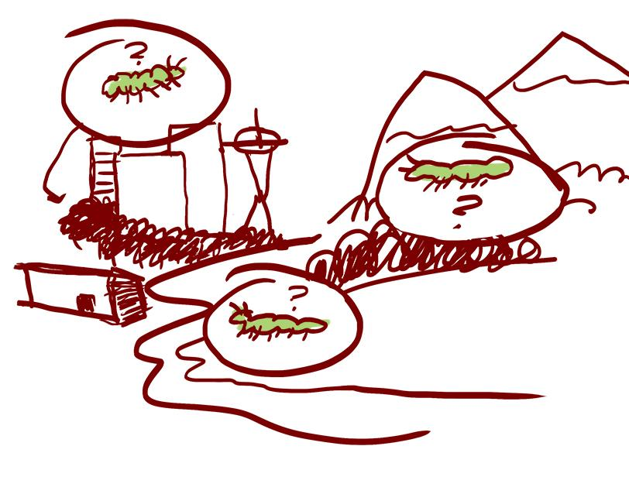
- What places, lands, and/or waters are involved in your “Should We” question?
- Who is involved in making decisions about these places, lands, and/or waters? Who is not involved in decision-making, and is that problematic? How so?
- How have these places, lands, and waters changed over time?
Thinking Across Scales (Time, Space, and Perspective)

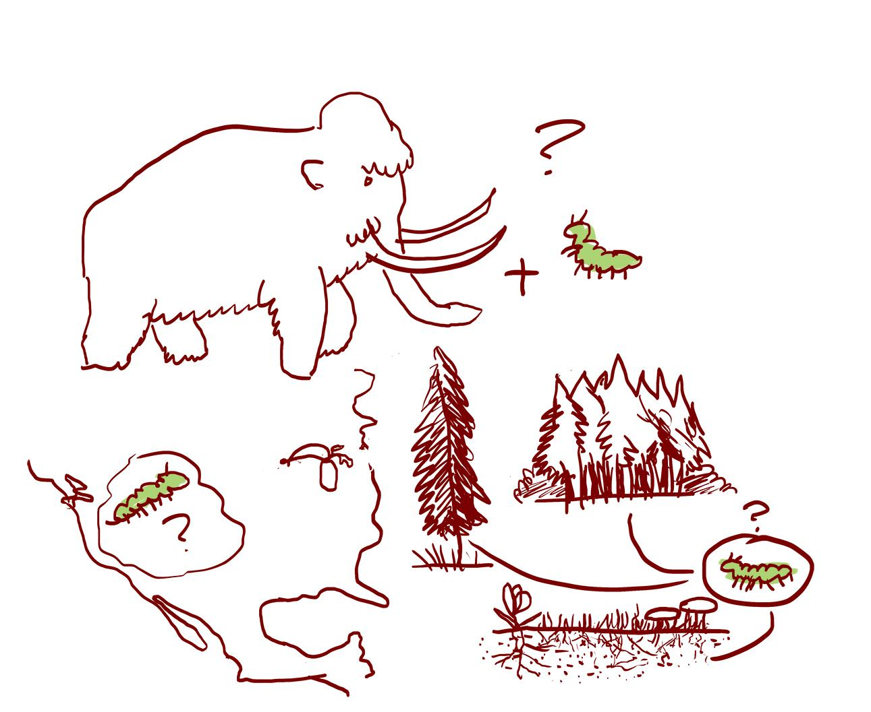
- What different time scales are important to think about related to your “Should We” question? (Look back at LE 1.C for some time scales you might consider.)
- What different scales related to space might be important to consider given your “Should We” question (looking at something from above or below, for example)?
- Try and take the perspective of species and kinds that you listed. Would doing that help you think about your “Should We” question differently?
Human Decision-Making

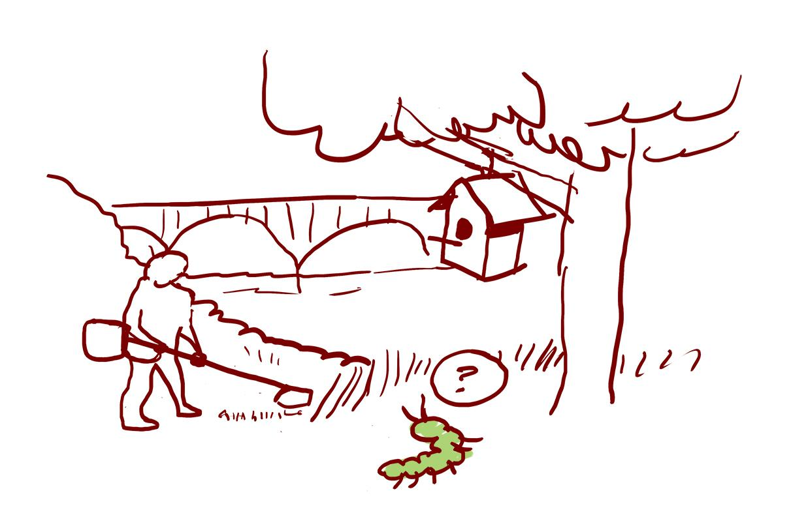
- What evidence of human-decision making is important to take into account given your “Should We” question?
- Who gets to make the decisions and why? Would different decisions be made if others were making the decisions?
- How could you find out the history of decision-making related to your “Should We” question? If you can find that out, what is that history?

Part C: Create an Initial Model of Your “Should We” Question
Now you are ready to create an initial model of your “Should We” question. You can use the next page to create your model or use a blank sheet of paper. Use drawings, words, diagrams, and arrows (and other symbols) to represent your family’s initial thinking about the dimensions of your “Should We” question that you noted in the chart in Part B. If you want to look at some examples of initial models, check the example guide.

If your “Should We” question is related to the initial model your family created in LE 5.C and/or LE 6.A, you can use that model and revise it, if needed, to reflect the thinking you have done in parts 1 and 2 of this activity.

After you create your initial model, you are ready for the activities in LE 6.B.2.

Our Family’s Initial Model of Our “Should We” Question

