Finding Out What Others Already Know about Our “Should We” Question

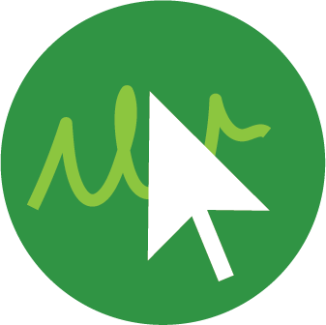
Deciding on what to research
Scientists often look to previous research to see what other people already know about the topic they are interested in studying. This helps them so that they can build on other people’s knowledge and create new knowledge! This kind of research can help scientists decide on a starting point for an investigation, explain their findings, or even raise new questions about their topic. This kind of research should be a part of the field-based and community-based research that you’re doing.

You can do research on a topic at the beginning of your investigation, in the middle, or at the end to try to explain what you found. The research you do can be in magazines, books, on websites, through podcasts, or in the newspaper. You have so many choices!

Keeping your research organized
As you do your research, it’s important to keep your information organized, and to remember where you found the information! You can use a table like the one below to organize your information:

Website/podcast/magazine/tv shows, book (etc.) | What we’re learning from this source | How this helps us explore our “Should We” question

What do you do next?
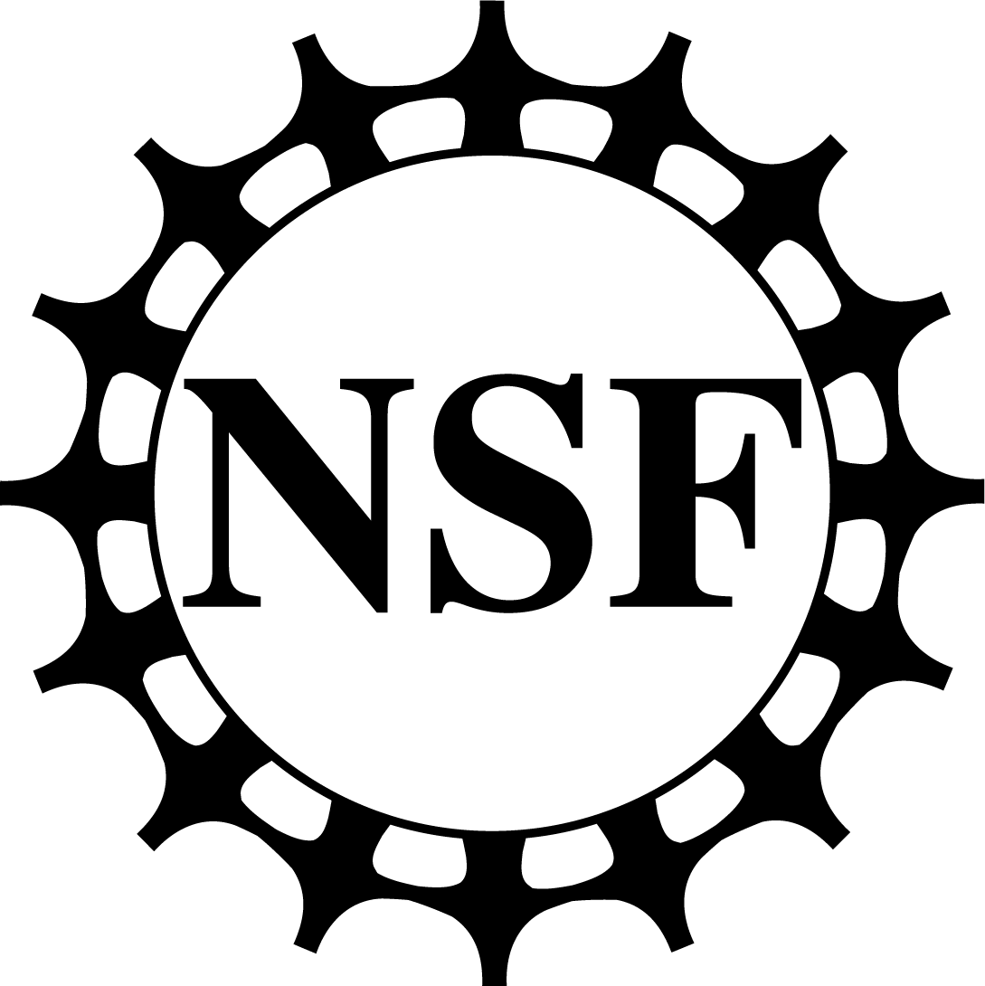
Remember that you’ll be doing a combination of field-based investigations (LE 7.A), community-based research (LE 7.B), and internet/book research (LE 7.c). Once you’ve done some research, you can go to LEs 8 and 9 to find some patterns across all of the data you’ve collected across all of your research. This will help you decide what your next steps are: either to do more investigations or to move to LE10 to take action on your “Should We” question.

