Returning to Our Models to Ask More Questions

Models are meant to be changed!

Now that you have connected your new learning with your family’s “Should We” question, it’s time to make some decisions about your next steps. You’ll do that by returning back to your model that you created in LE6.B.2 in order to see what you have learned and what you still need to learn.

Materials: For this LE, you’ll need
- your initial model from LE6.B.2
- some sticky notes or different colored pens or pencils to add to your model
- your data interpretation chart from LE

Part 1: Examining your model

Write your “Should We” question here:

_____________________________________________________________________________________________________

- Look over your initial model, and discuss as a family:
  - What relationships did you draw in this model?
  - Which relationships did you investigate and what did you learn?

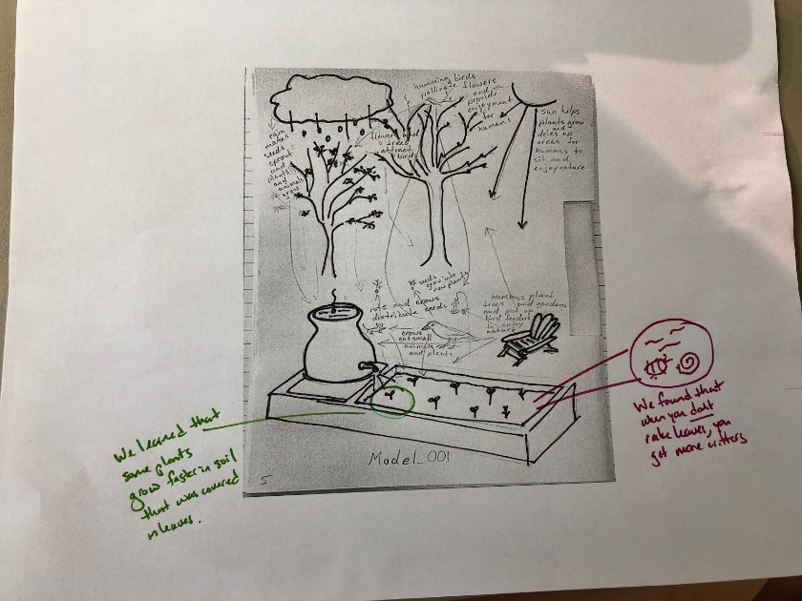
- Using a sticky note, colored pencils or markers, or anything else you have to write with:
  - If you learned something new that wasn’t in your initial model, add that to your model!
  - If you had something in your initial model that you now know shouldn’t have been there, you can cross it out!
  - If you identified a relationship in your initial model that you now know works differently than you originally thought, and/or involves other species, kinds, or behaviors than you originally thought, update your thinking in your model.
  - If you identified a relationship in your initial model that you now know is not central to understanding your “Should We” question, update your model and/or if you identified another relationship through your investigations that is central, add that to your model.
In the picture above, you can see that there is new knowledge added to the model in different colored pens. You can see that two different colors were used, meaning that we did two different investigations and added new knowledge after each investigation and our analysis of the data we collected!

- Next, discuss as a family: What relationships did we draw in our initial model that we have not yet investigated but still want to in order to better understand our “Should We” question?

Part 2: Decision time!

- Some questions your family can ask yourselves at this point are:
  - Do we feel like we have learned enough about our “Should We” question to share with others what we have learned and to take some action?
  - Do we feel like there is still more that we can and should learn about before we share with others and take action?

- If there are still more relationships that you want to explore, go back to LE7 and decide on what field-based investigations, community interviews, and/or other research about what others already know you want to do.

- If your family feels like you’re ready to move on, go to LE 10!

