Family Focused Wondering Walk

Please return your observations and wonderings by: ____________________________

Hello, Classroom Families!

As you know, our class has been observing and wondering about places outside our school. We have been exploring ideas like size, scale, and relationships. You have helped us with this work by taking your own walks in your neighborhood, making observations, and posing wonderings. Thank you!

We grouped all of these observations and wonderings from our neighborhoods and school into phenomena. We have defined “phenomena” as events, behaviors, relations, or ideas that we can observe and investigate, like trees budding or bees landing on flowers. After we did this, we picked a few of these phenomena that are interesting to us and that are related to a type of question we are asking called a “Should We” question. Our class “Should We” question is:

_______________________________________________________________________________________________________________

The phenomena we picked that are related to our “Should We” question are:

1. ________________________________________________________________________________________

2. ________________________________________________________________________________________

Activity Purpose: We would like your help again! Please pick one of our phenomena to observe in different places or over time.
If you picked phenomenon 1, please observe it ____________________________________________________________

If you picked phenomenon 2, please observe it ____________________________________________________________

The places and/or times you choose for observations are up to you. If you only have time for one and/or two walks, that is fine! Please only do what you have time for. Make sure to record any wonderings you have as you observe. Draw or write what you observe using the sheets in this packet or you can do this work on blank sheets of paper if you want. Include what is above, around, and below the phenomenon. Use arrows or words to show relationships. Use a new sheet for each observation.

If it’s raining or you forget something to write on, you can take pictures of what you notice or simply remember them. You can then draw and write about your observations and wonderings when you get back inside.

What you can do to support learning:
- What kinds of roles and relationships do you notice related to the phenomenon you chose?
- What similarities and/or differences do you notice across places and over time? Similarities and differences help us see patterns in our world.
- Remember that there are no right answers. We want to collect as many observations of our focal phenomena and wonderings about those observations as we can!

The phenomenon we observed is (pick #1 or #2 from the list below): ________________________________________________________________________________

________________________________________________________________________________

We observed this phenomenon in these three different places:

___________________________________________________________________________

___________________________________________________________________________

___________________________________________________________________________

OR

We observed this phenomenon at three different times (what times did you observe?):

_________________________________________________________________________________________________________________

The season is: _____________________ The weather during our walk is (circle one): 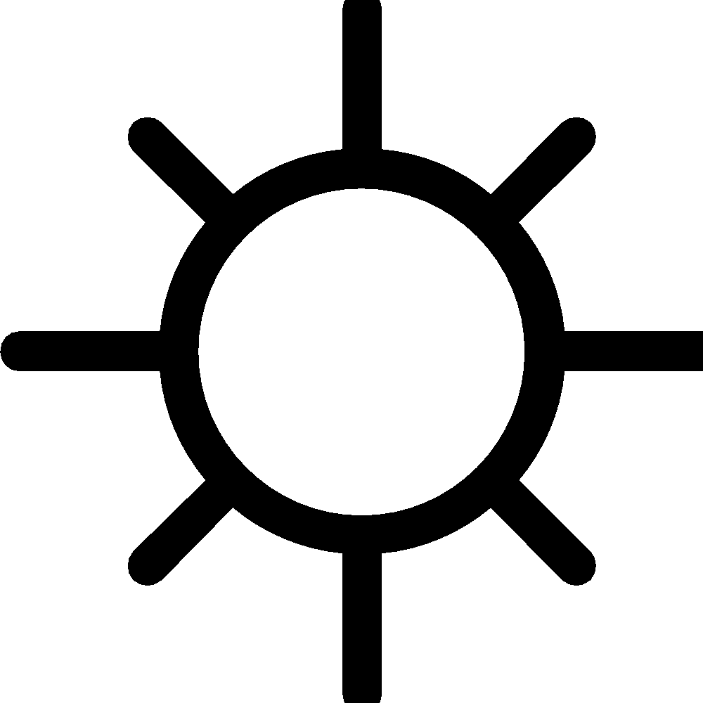 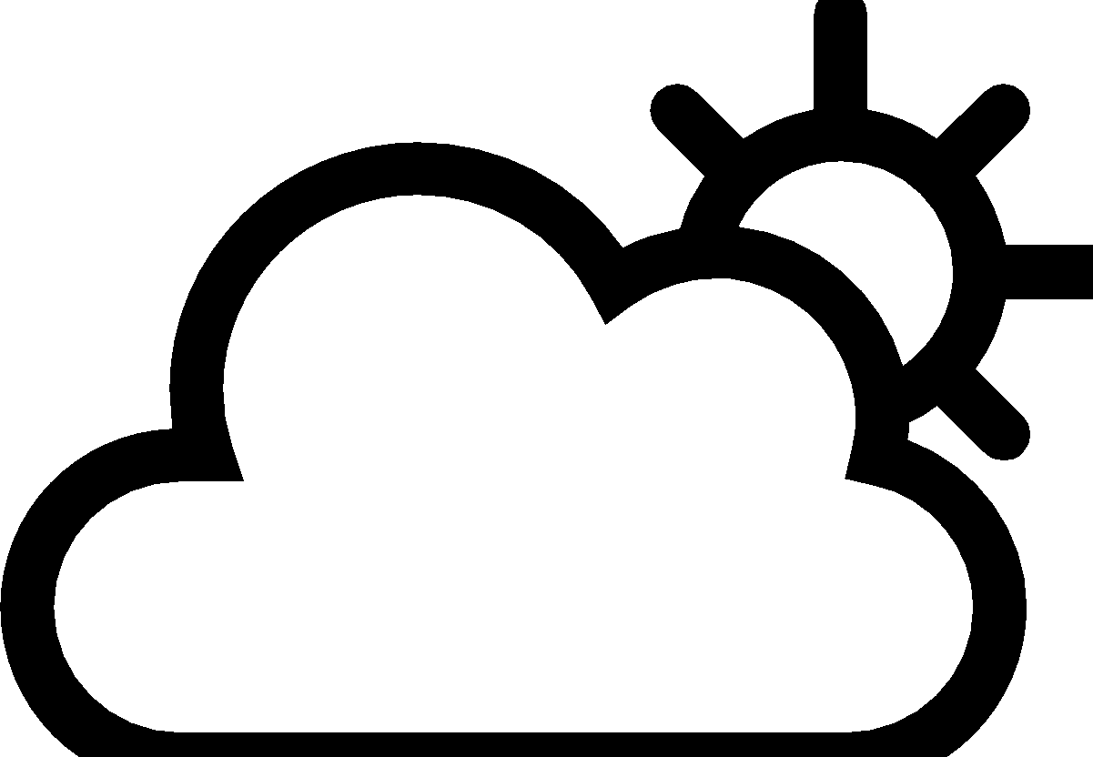 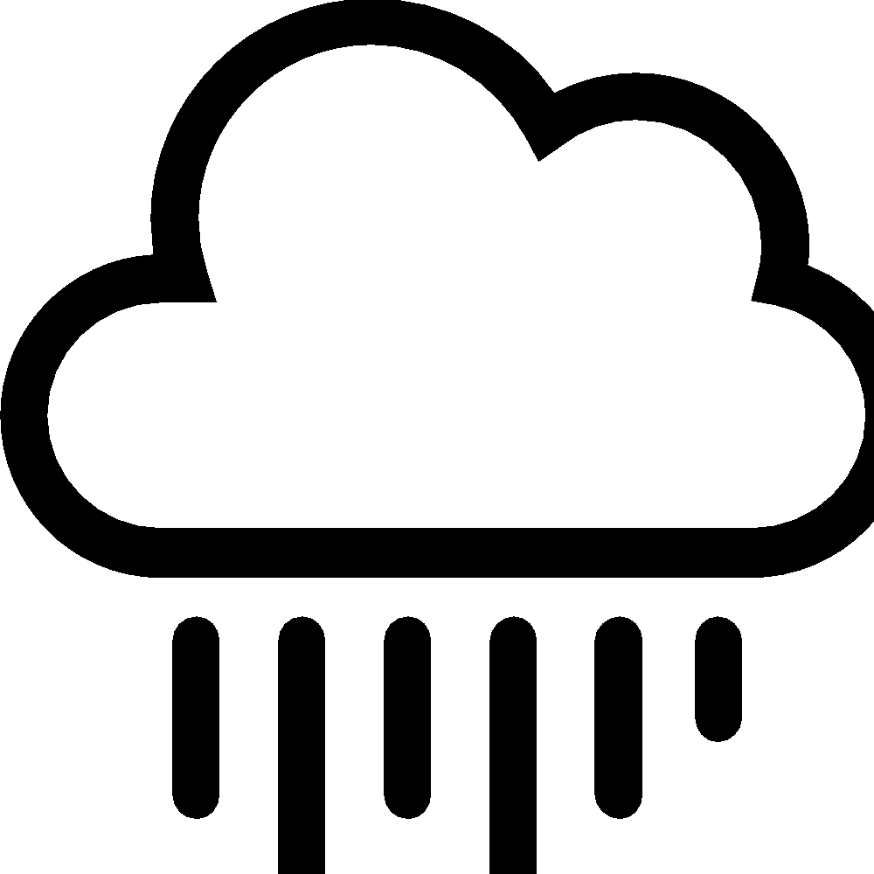 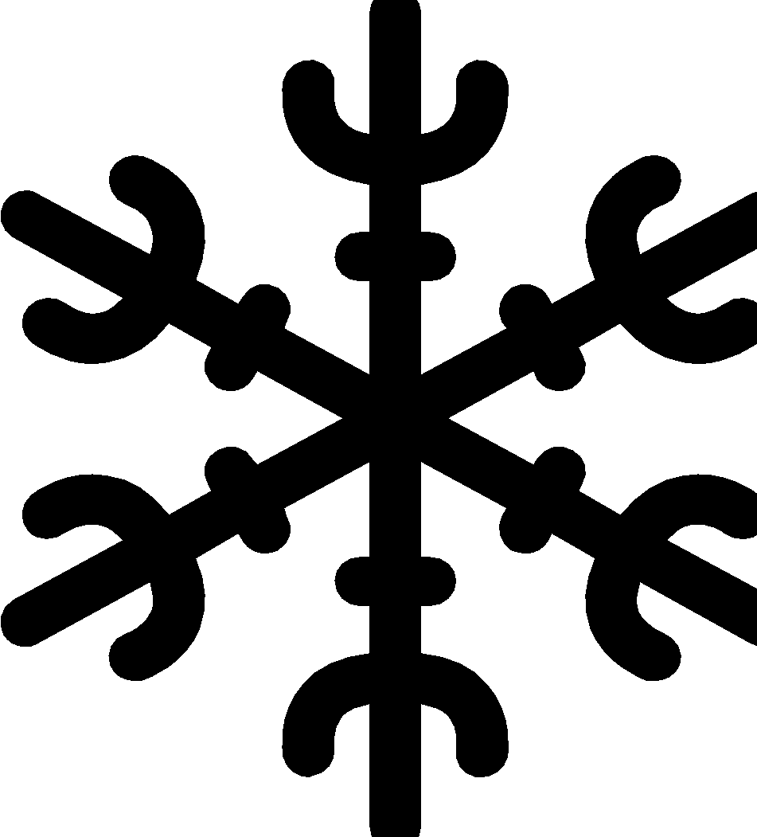 The temperature during our walk is: ____________________

Walk #1
Location 1: _____________________ Time: _______________________
Weather:
Temperature: ________________
Draw what you observe here.
↑above

around
← →

↓ below
We Wonder…

Walk #1 continued…
Now that you have observed this phenomenon from above, below, and around, what relationships are part of this phenomenon that you think are important to highlight? Put a star or a check mark in the box to the left of any relationship you observe that you think is an important part of this phenomenon. (Don’t worry if you do not observe all of these types of relationships. Just check the ones you do observe.)

If you haven’t already drawn or written about the relationships you checked, go back to your drawing and add them in. Also, if you have new wonderings after observing any of these relationships, write those down too.

 | Animal-Animal |  | Animal-Plant
 | Animal-Human |  | Plant-Plant
 | Plant-Human |  | Animal-Natural Kind (for example: water, rock, sun, air)
 | Plant-Natural Kind (for example: water, rock, sun, air) |  | Human-Natural Kind (for example: water, rock, sun, air)
 | Human-Human |  | Other?

Walk #2
Location 2: _____________________ Time: _______________________
Weather:
Temperature: ________________
Draw what you observe here, including relationships.
↑above

around
← →

↓ below
We Wonder…

Walk #2 continued…
Now that you have observed this phenomenon from above, below, and around, what relationships are part of this phenomenon that you think are important to highlight? Put a star or a check mark in the box to the left of any relationship you observe that you think is an important part of this phenomenon. (Don’t worry if you do not observe all of these types of relationships. Just check the ones you do observe.)

If you haven’t already drawn or written about the relationships you checked, go back to your drawing and add them in. Also, if you have new wonderings after observing any of these relationships, write those down too.

Something to think about: Are there relationships that you observed on this walk that you didn’t observe on Walk #1? Why do you think that is? Or, did you observe relationships on Walk #1 that you didn’t observe on this walk? Again, why might that be?

 | Animal-Animal |  | Animal-Plant
 | Animal-Human |  | Plant-Plant
 | Plant-Human |  | Animal-Natural Kind (for example: water, rock, sun, air)
 | Plant-Natural Kind (for example: water, rock, sun, air) |  | Human-Natural Kind (for example: water, rock, sun, air)
 | Human-Human |  | Other?

Walk #3
Location 3: _____________________ Time: _______________________
Weather:
Temperature: ________________
Draw what you observe here, including relationships.
↑above

around
← →

↓ below
We Wonder…

Walk #3 continued…
Now that you have observed this phenomenon from above, below, and around, what relationships are part of this phenomenon that you think are important to highlight? Put a star or a check mark in the box to the left of any relationship you observe that you think is an important part of this phenomenon. (Don’t worry if you do not observe all of these types of relationships. Just check the ones you do observe.)

If you haven’t already drawn or written about the relationships you checked, go back to your drawing and add them in. Also, if you have new wonderings after observing any of these relationships, write those down too.

Something to think about: Are there relationships that you observed on this walk that you didn’t observe on Walks #1 and/or #2? Why do you think that is? Or, did you observe relationships on Walks #1 and/or #2 that you didn’t observe on this walk? Again, why might that be?

 | Animal-Animal |  | Animal-Plant
 | Animal-Human |  | Plant-Plant
 | Plant-Human |  | Animal-Natural Kind (for example: water, rock, sun, air)
 | Plant-Natural Kind (for example: water, rock, sun, air) |  | Human-Natural Kind (for example: water, rock, sun, air)
 | Human-Human |  | Other?

