Wondering Walks to Observe Focal Phenomena Related to Our “Should We” Question

Name: ____________________________________________ Today’s Date: __________________

The season is: _______________________________________

The weather during our walk is: 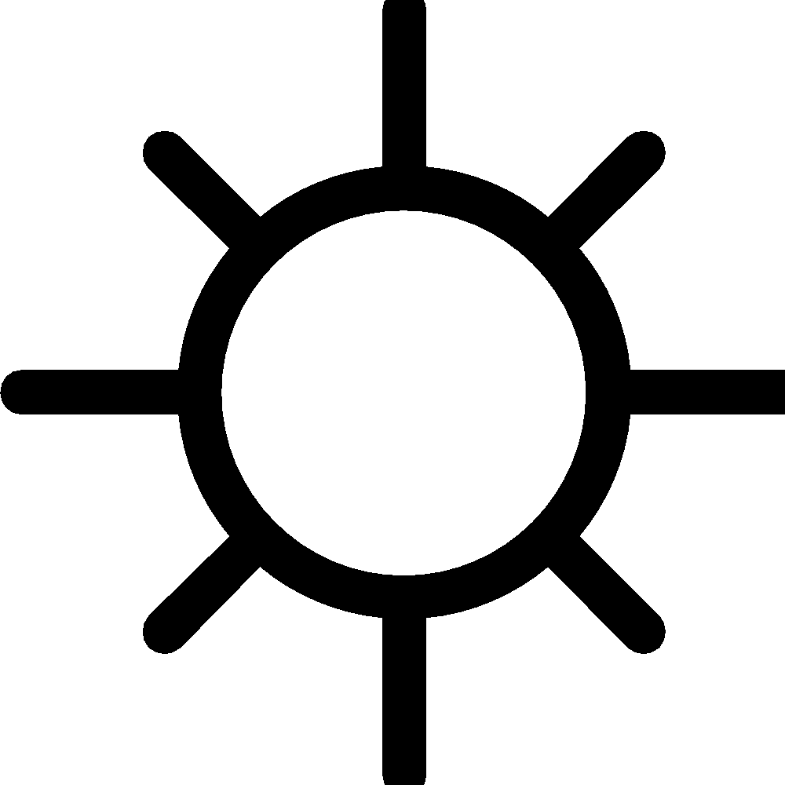 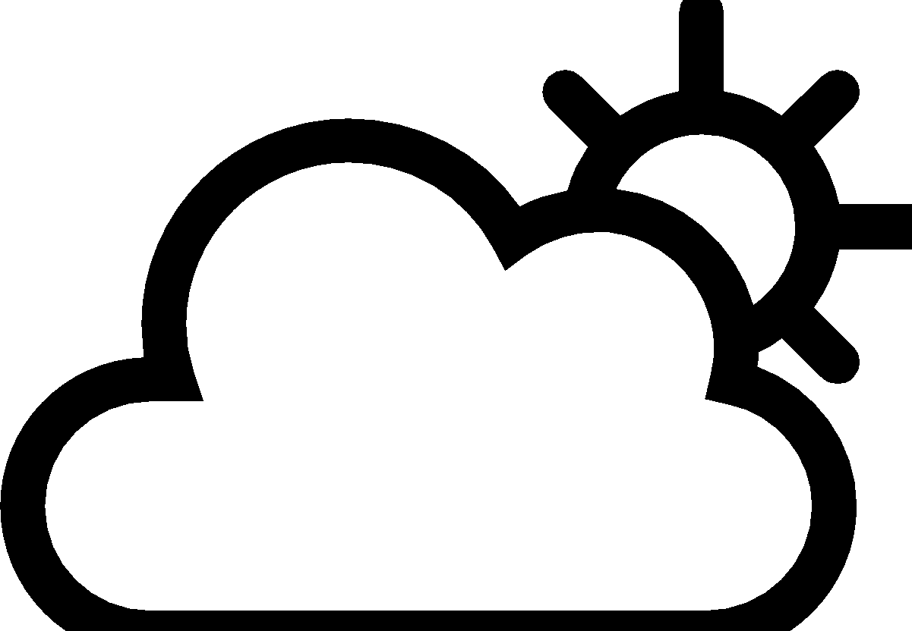 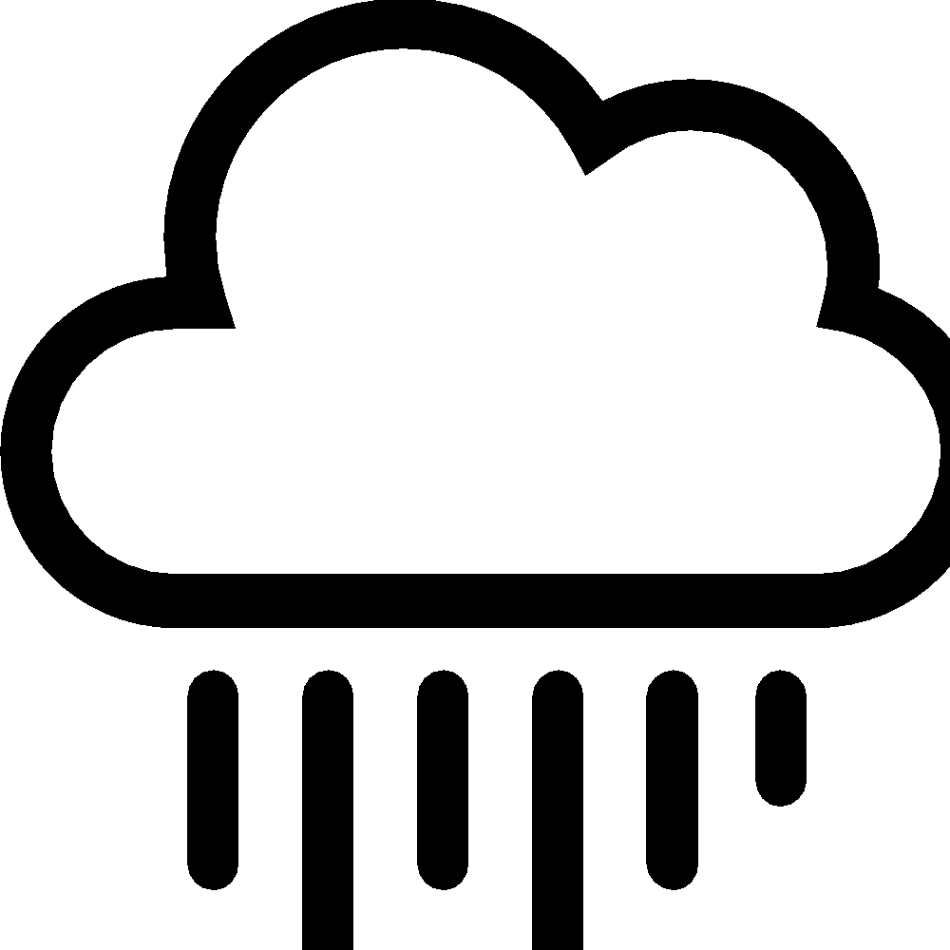 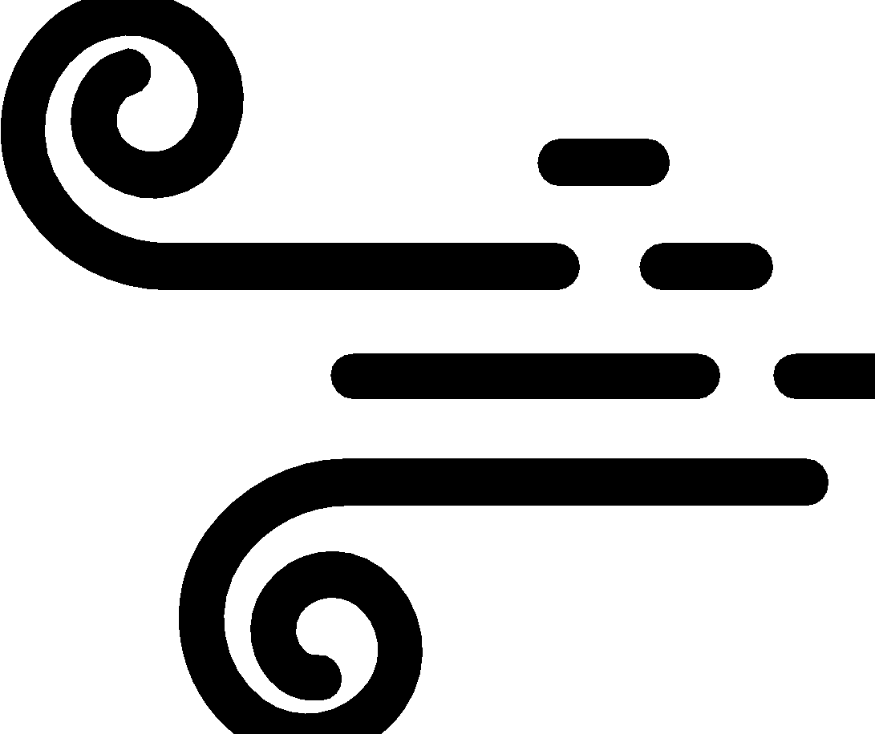
The temperature during our walk is: ____________________
Our “Should We” Question is:
_________________________________________________________________________________

We are observing these phenomena when we go outside: ________________________________________________________________________________________

________________________________________________________________________________________

Part A: Preparing for Our Walk
Before we go outside, we need to do some thinking about where we are going to walk, when, and why. Let’s answer these questions so that we have a plan when we go outside.

1. Where do you think we will find these phenomena outside? Where should we look? If we need to observe these phenomena during three different times, what times should we go observe? Why? Write down your ideas.
________________________________________________________________________________________

________________________________________________________________________________________

________________________________________________________________________________________

________________________________________________________________________________________

2. What are some things we should think about when we are observing these phenomena? Circle the dimensions you think will be important for us to use. For each dimension you circle, write your reason for circling it underneath the picture.
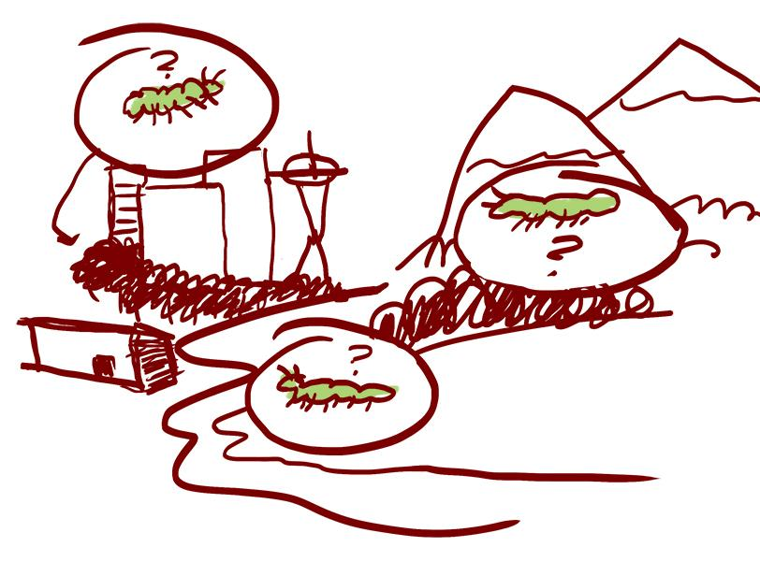
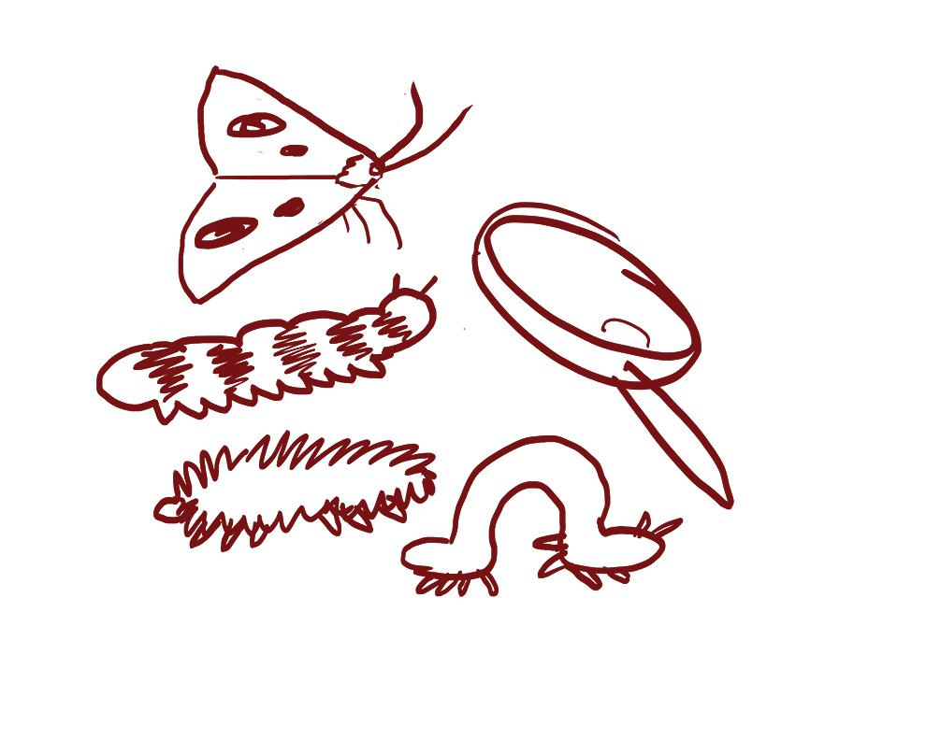
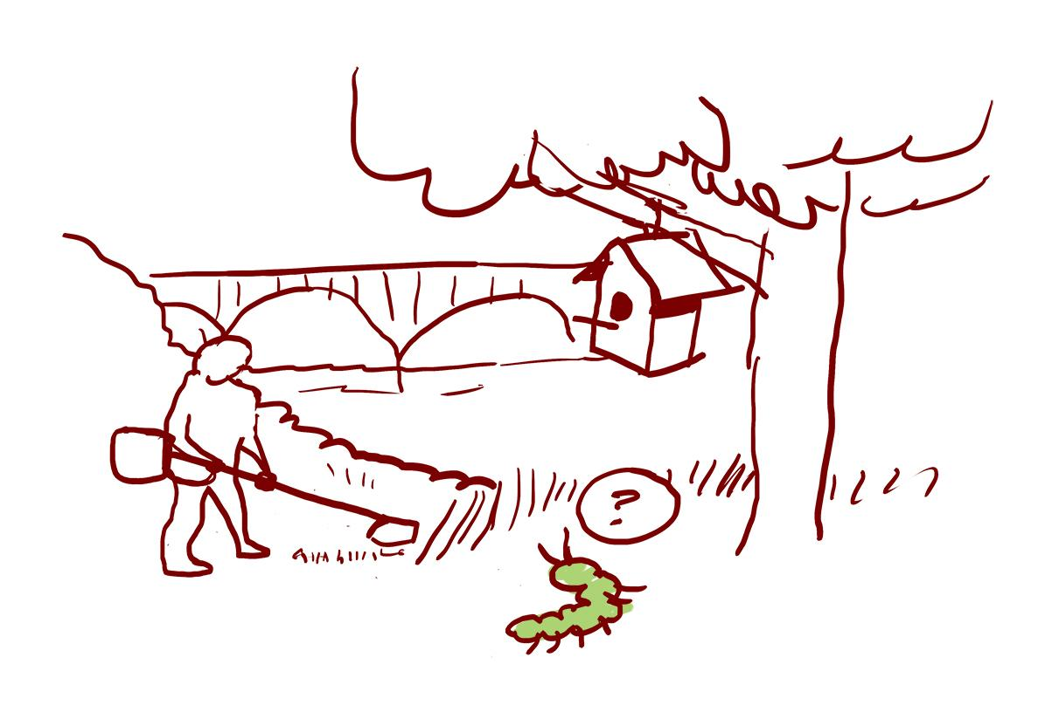
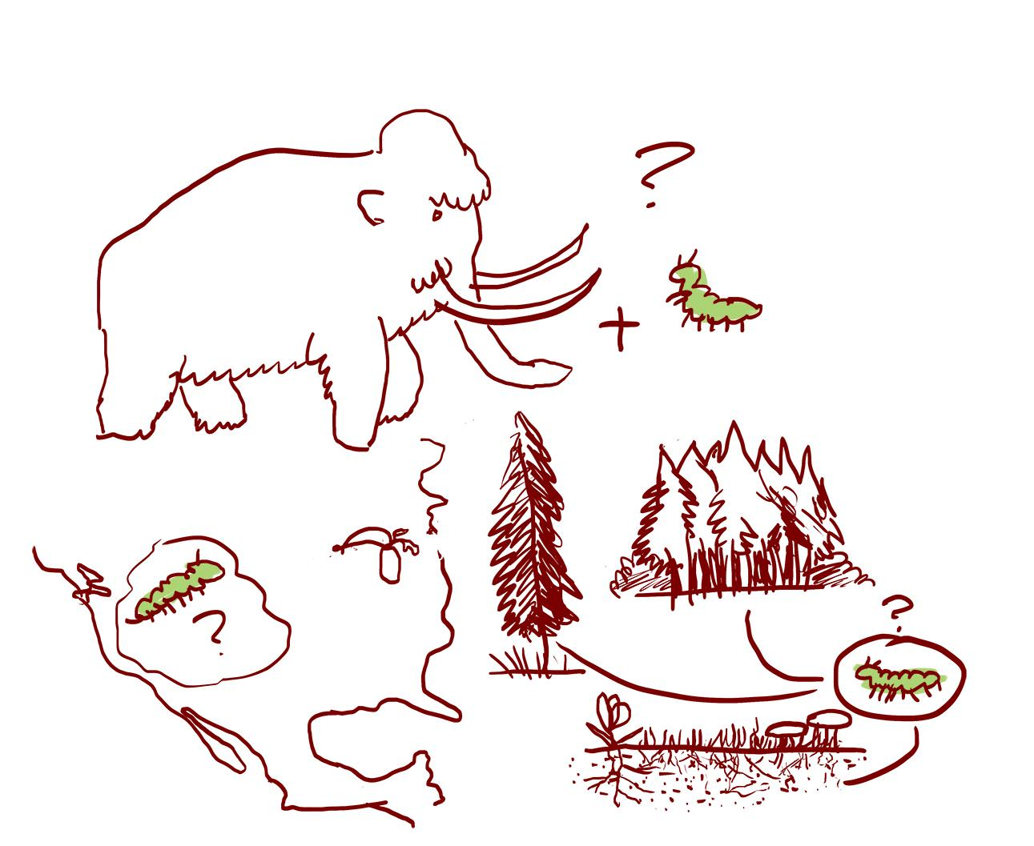
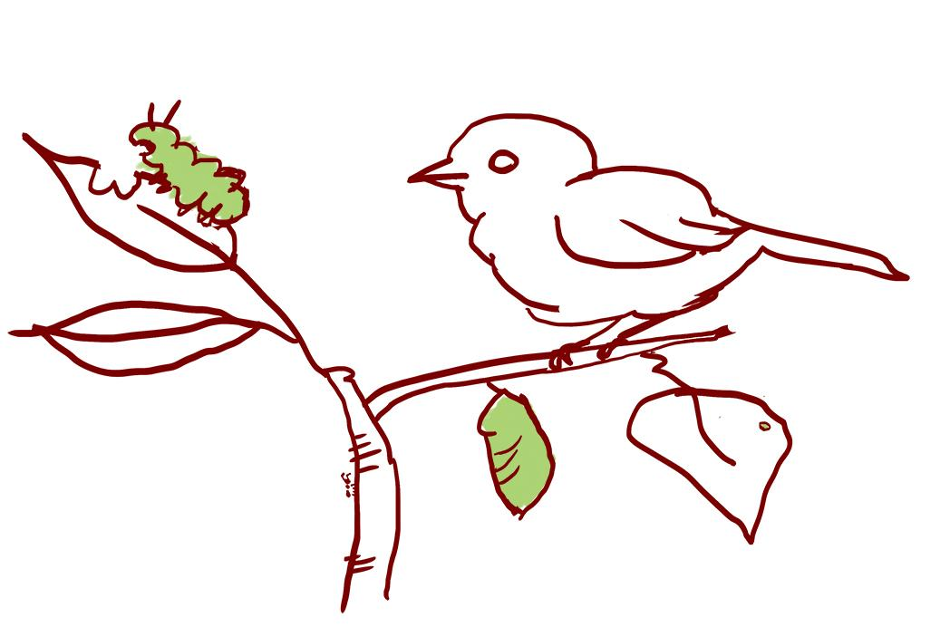

Species, Kinds, and Relationships Places, Lands, & Thinking across Human
Behaviors Water Scales Decision-Making

What questions do you have before we go outdoors?

_________________________________________________________________________________

_________________________________________________________________________________

_________________________________________________________________________________

Part B: Talking Our Walk (Use the plan we made. Write and draw observations and wonderings.)
Walk #1
Location 1: _____________________ Time: _______________________
Weather:
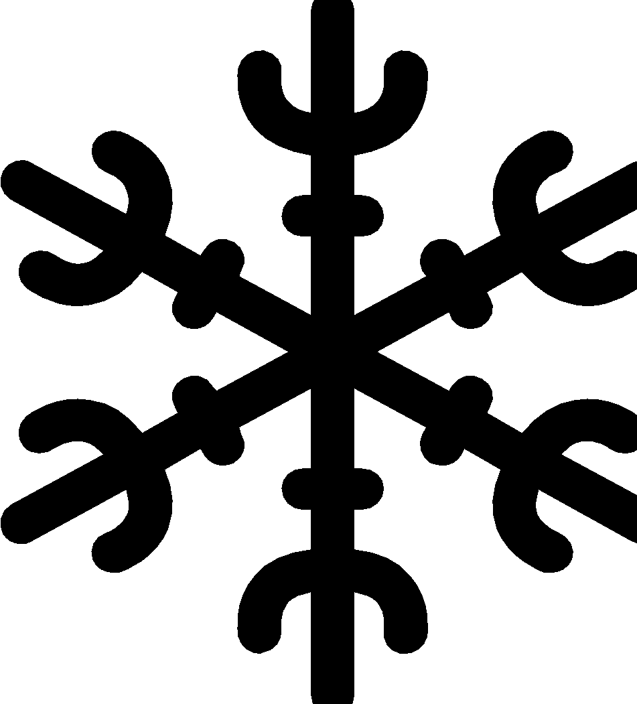 Temperature: ________________
Draw what you observe here, including relationships.
↑above

around
← →

↓ below
I Wonder…

Walk #1 continued…
Now that we have observed our focal phenomena from above, below, and around, what relationships are part of these phenomena that you think are important for us to highlight? Put a star or a check mark in the box to the left of any relationship you observe that you think is an important part of these phenomena.

If you haven’t already drawn or written about the relationships you checked, go back to your drawing and add them in. Also, if you have new wonderings after observing any of these relationships, write those down too.

 | Animal-Animal |  | Animal-Plant
 | Animal-Human |  | Plant-Plant
 | Plant-Human |  | Animal-Natural Kind (for example: water, rock, sun, air)
 | Plant-Natural Kind (for example: water, rock, sun, air) |  | Human-Natural Kind (for example: water, rock, sun, air)
 | Human-Human |  | Other?

Walk #2
Location 2: _____________________ Time: _______________________
Weather:
Temperature: ________________
Draw what you observe here, including relationships.
↑above

around
← →

↓ below
I Wonder…

Walk #2 continued…
Now that we have observed these phenomena from above, below, and around, what relationships are part of these phenomena that we think are important to highlight? Put a star or a check mark in the box to the left of any relationship you observe that you think is an important part of this phenomenon.

If you haven’t already drawn or written about the relationships you checked, go back to your drawing and add them in. Also, if you have new wonderings after observing any of these relationships, write those down too.

Something to think about: Are there relationships that you observed on this walk that you didn’t observe on Walk #1? Why do you think that is? Or, did you observe relationships on Walk #1 that you didn’t observe on this walk? Again, why might that be?

 | Animal-Animal |  | Animal-Plant
 | Animal-Human |  | Plant-Plant
 | Plant-Human |  | Animal-Natural Kind (for example: water, rock, sun, air)
 | Plant-Natural Kind (for example: water, rock, sun, air) |  | Human-Natural Kind (for example: water, rock, sun, air)
 | Human-Human |  | Other?

Walk #3
Location 3: _____________________ Time: _______________________
Weather:
Temperature: ________________
Draw what you observe here, including relationships.
↑above

around
← →

↓ below
I Wonder…

Walk #3 continued…
Now that you have observed these phenomena from above, below, and around, what relationships are part of these phenomena that you think are important to highlight? Put a star or a check mark in the box to the left of any relationship you observe that you think is an important part of these phenomena.

If you haven’t already drawn or written about the relationships you checked, go back to your drawing and add them in. Also, if you have new wonderings after observing any of these relationships, write those down too.

Something to think about: Are there relationships that you observed on this walk that you didn’t observe on Walks #1 and/or #2? Why do you think that is? Or, did you observe relationships on Walks #1 and/or #2 that you didn’t observe on this walk? Again, why might that be?

 | Animal-Animal |  | Animal-Plant
 | Animal-Human |  | Plant-Plant
 | Plant-Human |  | Animal-Natural Kind (for example: water, rock, sun, air)
 | Plant-Natural Kind (for example: water, rock, sun, air) |  | Human-Natural Kind (for example: water, rock, sun, air)
 | Human-Human |  | Other?

