Asking Investigation Questions: What more do you want to know?

Now that we have observed and modeled the phenomena in our “Should We” question, we are going to brainstorm investigation questions that we can ask!

Our “Should We” question is __________________________________________________________________

The phenomena we observed __________________________________________________________________

5 Socio-ecological Dimensions | Investigation Questions | Data we could collect
What more do we want to know about the species, kinds and behaviors that we observed wondering walks? 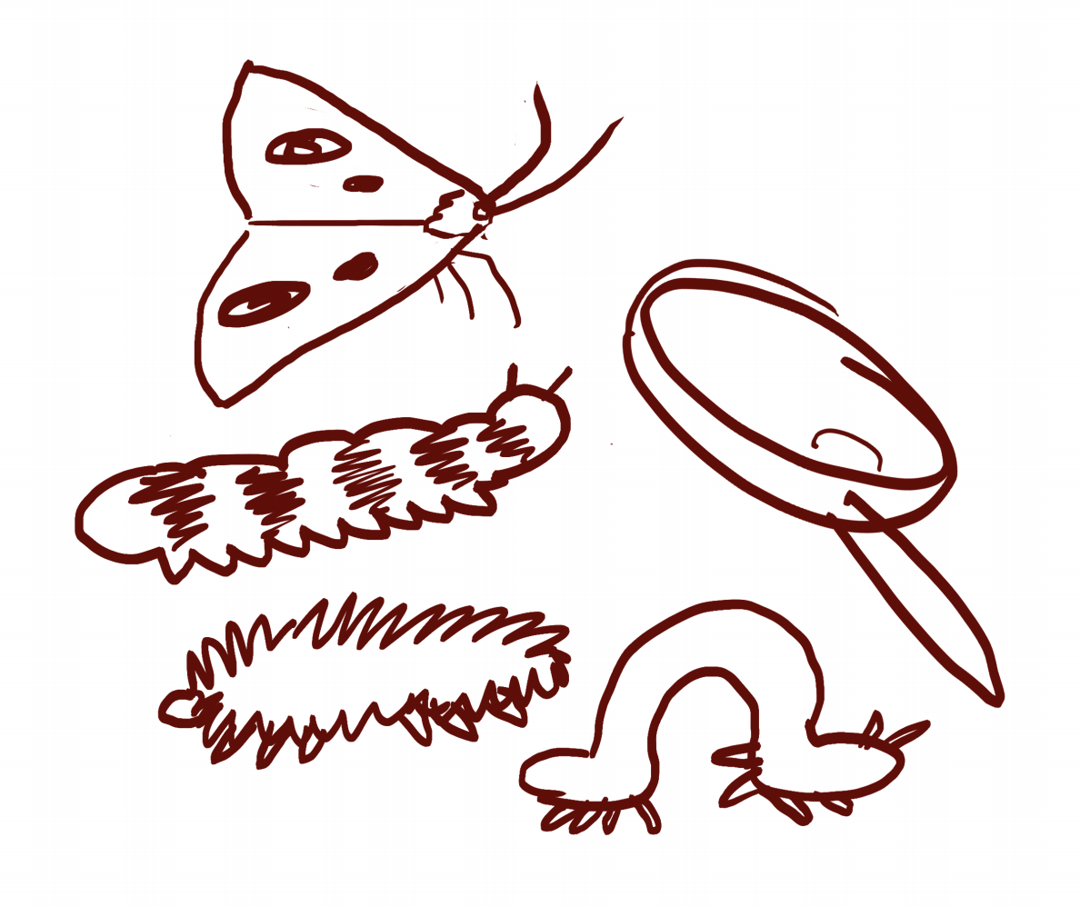
What more do we want to learn about the relationships that we observed?
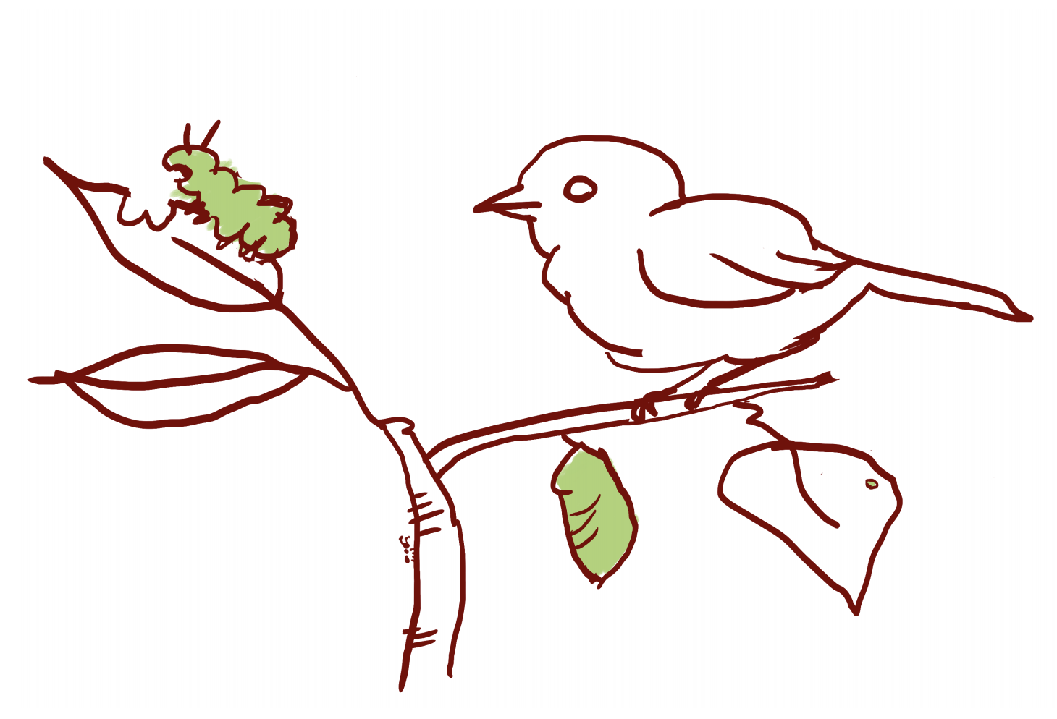
How can we learn more about the places, lands, & waters where we live?
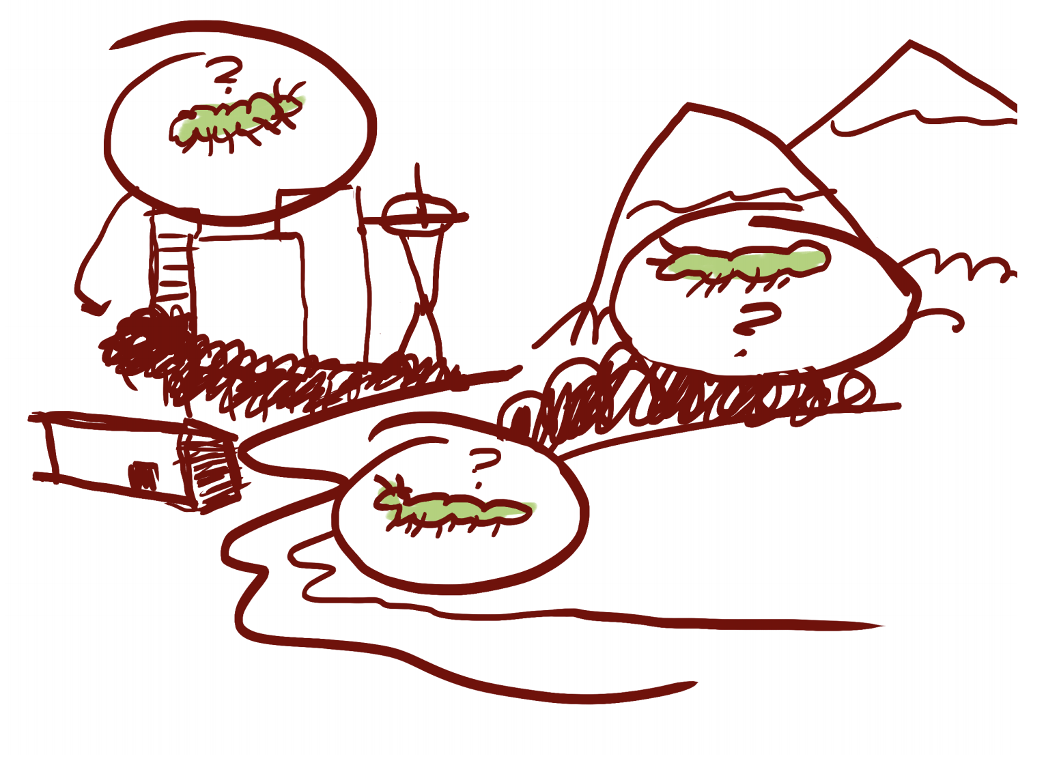

How can we consider time and space (scale) as we conduct our investigations?
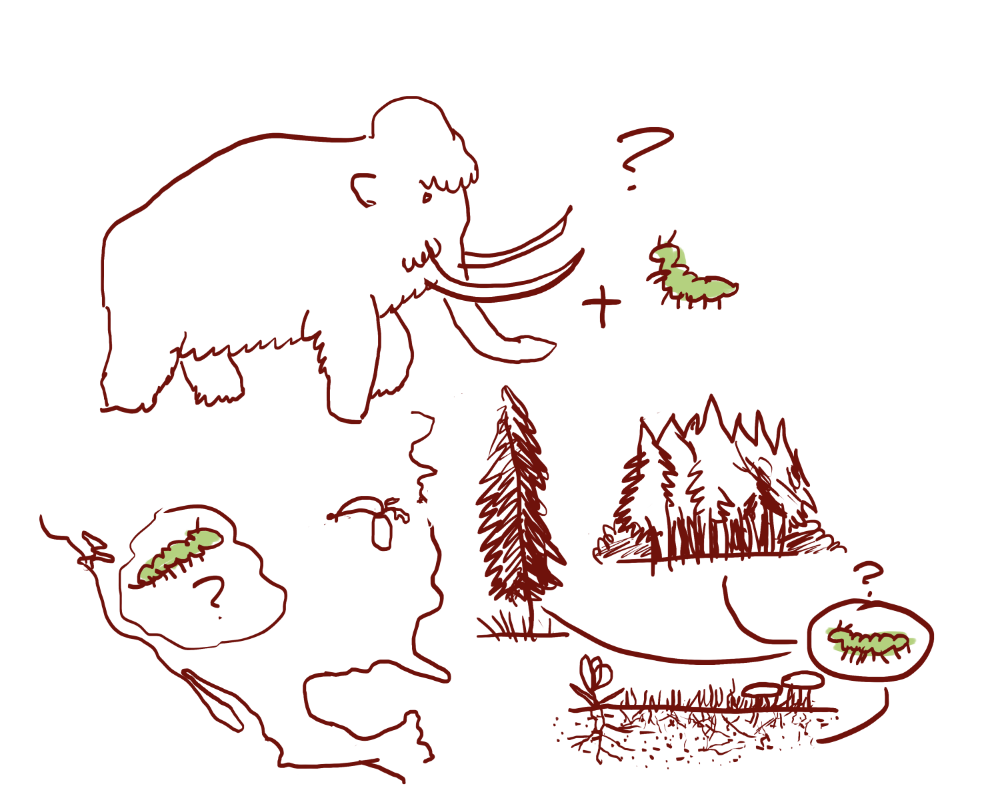
How does human decision-making affect where we live?
