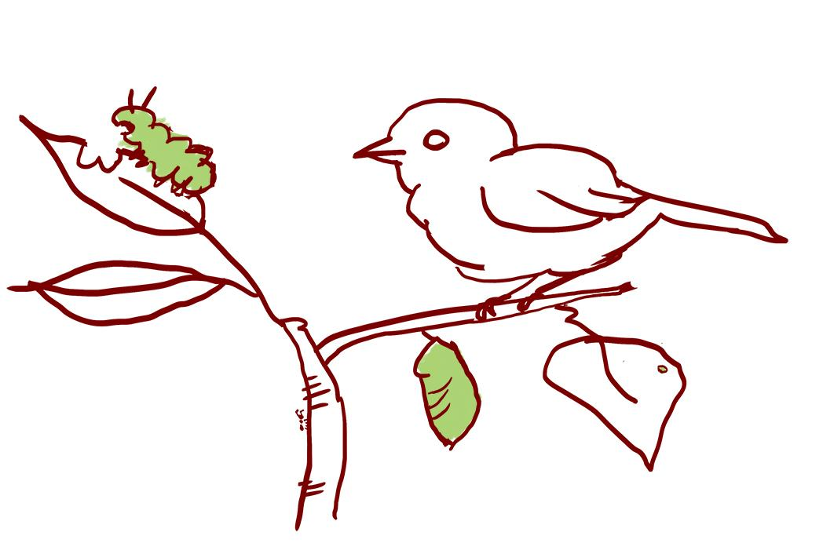
LE 2.4 Focused wondering walk: Relationships
Please return by__________________________

Relationships: Relationships are the ways in which beings interact with each other. For example, how does the behavior of water change with the weather? Which plants do you typically see caterpillar munching on? What plants do people step on and which ones do they protect?

Activity Purpose:
We are investigating relationships in the natural world around the school. Learning to notice relationships in the social and natural world is important for thinking about socio-ecological systems. Focusing on relationships among different members and parts of a system helps us understand the many ways in which everything is connected. You might notice relationships between humans and plants, directly or indirectly, when you notice things humans have built. For example, you might notice plants growing in the cracks of sidewalks or in yards. Or you might notice relationships between animals, like a dog chasing a squirrel. You can also look for relationships between the land and water.

Activity Overview:
- Use the activity sheet to guide your thinking while you walk.
- Look for signs of relationships and draw or write anything interesting that you see.
- If any new questions come up, write them down and come back to them later to see if you have additional thoughts about them.

What can you do to support learning:
- Talk about relationships in your own family, and don't forget to mention neighbors, teachers, pets, plants, etc. Ask children what they think is important about those relationships. While you walk, look for examples of relationships in the neighborhood. Who is in a relationship with whom? Why? What does it remind you of?
- Pay attention to what captures your family's interest. Look above, below and around to discover what might be in relation with each other. What kinds of relationships are you noticing? Who or what benefits from these relationships?
- Can you find a relationship that is not directly connected, but still part of the bigger system?

Draw or write down any signs of relationships that you notice. What do they make you wonder? | We noticed:  ____________________________  ____________________________  ____________________________  ____________________________  ____________________________  ____________________________  ____________________________  ____________________________
We wonder:

______________________________

______________________________

______________________________

______________________________

______________________________

______________________________

______________________________

______________________________

______________________________

______________________________

______________________________

______________________________

