Scientist’s Name Date

What is the Current Season?
We want to learn more about seasons in this place. We are going to take a walk and use all of our senses to find evidence of the season.

What season do you think it is in this place?

What is the weather during our walk? Circle the picture of the weather (you can circle more than one).

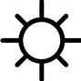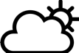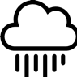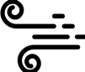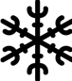

Now you are going to make some observations in this place. What do you hear? What do you see? What do you smell? What does something feel like if you touch it (make sure it is okay to touch!)?
My observations using my senses  In each box, write or draw what you hear, what you touch, what you smell, and what you see. |  | This makes me wonder about….  Now draw or write any questions or wonderings about what you heard, touched, smelled, and saw in this place.
hearing

touch

smell

sight
Look back at the season you think it is in this place (page 1). What observations did you make that convince you that it is this season?

