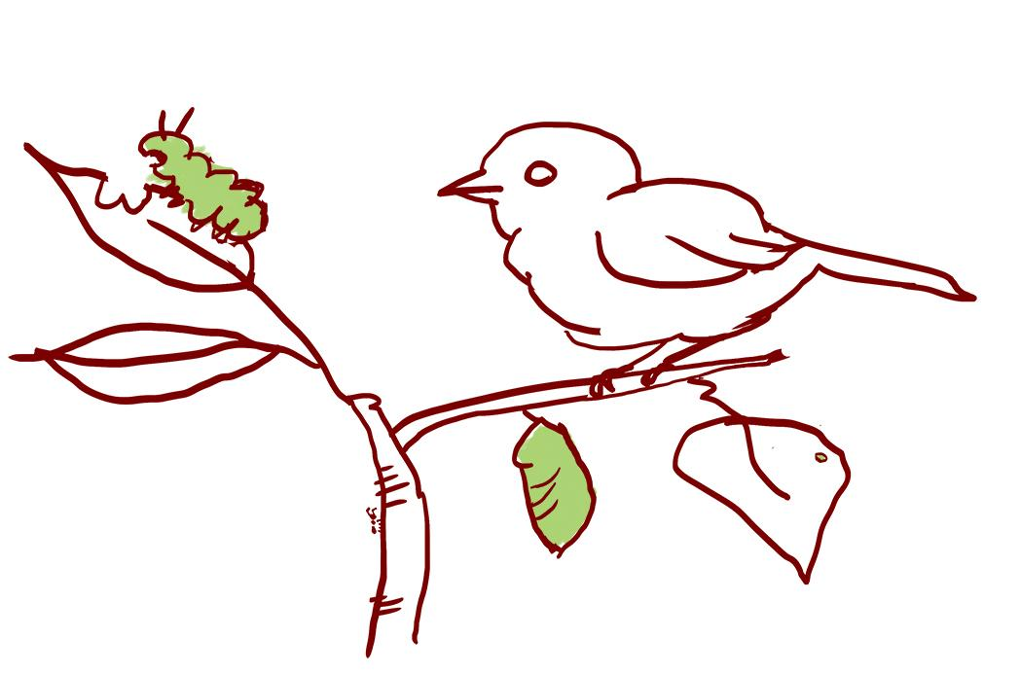
LE 2.4 Relationships wondering walk

Relationships: Relationships are the ways in which beings interact with each other. For example, how does the behavior of water change with the weather? Which plants do you typically see caterpillar munching on? What plants do people step on and which ones do they protect?

Draw or write down any signs of relationships that you notice. What do they make you wonder? | We noticed:  ____________________________  ____________________________  ____________________________  ____________________________  ____________________________  ____________________________  ____________________________  ____________________________
We wonder:

______________________________

______________________________

______________________________

______________________________

______________________________

______________________________

______________________________

______________________________

______________________________

______________________________

______________________________

______________________________

