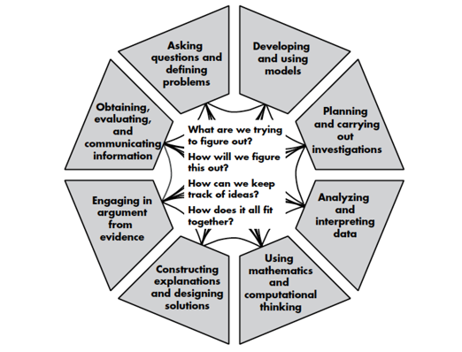
LE 8.1 SUMMARY TABLE
Overview: In our storyline, learning activities are sequenced to support deep learning about phenomena in this place and during this season so that we can better understand and make decisions about social and ecological systems that matter to us. Across a seasonal storyline, students will engage in a variety of activities and will need scaffolding to make sense of the phenomena that they are studying. Throughout, we are always connecting back to the key questions: “1) What are we trying to figure out?; 2) How will we figure it out?; 3) How can we keep track of ideas?; and 4) How does it all fit together?”
The graphic organizer below is meant to help track, organize, and synthesize learning over time in order to explicitly connect back to these central driving questions.
How to use this tool: We recommend that teachers fill out this form first before introducing it to the class. This can help teachers demonstrate how to trace the investigation cycle and pop out patterns in connection with the bigger investigation. This is also a time to think about the final activity and record what criteria you want to see reflected in students’ final explanations.
Note: While there may be many activities (including in literacy, mathematics, and social studies!) that contributed to the overarching seasonal storyline, not every activity needs to be incorporated in the summary table. Consider the major activities (in the field, garden, and homes) that drove the storyline investigation.
Here are some examples of possible ways to use this tool:
- Throughout the seasonal storyline, use this tool as a classroom artifact that frames the activity or learning engagement (what are we trying to figure out; how will we figure it out) and shapes the discussion afterwards (how can we keep track of ideas; how does it all fit together).
- If you are at the end of your data collection and sensemaking cycle, collectively fill out the “Should we” question/s and first two columns. This will help students remember the driving “Should we” question, the investigative questions, and the data that was collected. Then, students can reflect on what they learned.
Investigation Summary Table
Our “Should we” question is: __Should we add worms to our garden?_________________________________
Description of Activity: What were we trying to figure out? [Include any investigation questions] | What data did we gather? | What did we learn from our family tools related to our “Should we” Question? | How does what we learned relate to seasons? | What should we make sure to include in our final explanation and model? [include 5 socio-ecological dimensions] | What did I learn from this activity that helps me answer our investigation question? | What did I learn from this activity that helps me answer my “Should we” question?
Example: Our investigation question was “Where can we find worms?”  We wanted to figure out if there were more worms in the garden bed or in the forest under the log. | Example: We counted the number of worms we found in each place.  Note: it was raining and some of us wondered if there were fewer worms in the garden because it was not covered like in the forest. | Example: [From Family “Should we” Model] If we add worms to our garden, in 10 years we may save lots of money on fertilizer.  Note: We are imagining the long-term impacts of worms in the soil as a sustainable alternative to buying fertilizer. | Example: In the fall there are lots of leaves falling. Worms help leaves break down and become nutrients for other plants and animals. | Example: Worm habitat; role of worms in ecosystem; web reasoning (worms, millipedes, and fungus all play a role in breaking down dead leaves and logs; birds eat worms, seeds, and other bugs; people use worms in the gardens, to go fishing, and to feed their pets). | Example: We learned that there were more worms under the log than in the garden bed. We think this is because worms like the nutrients from the dead leaves and dead log. We also think worms might be “safer” from predators. | Example: If we are going to put worms in our garden, we should add dead things for them to eat.
Investigation Summary Table
Our “Should we” question is: __________________________________________________________________________
Description of Activity: What were we trying to figure out? [Include any investigation questions] | What data did we gather? | What did we learn from our family tools related to our “Should we” Question? | How does what we learned relate to seasons? | What should we make sure to include in our final explanation and model? [include 5 socio-ecological dimensions] | What did I learn from this activity that helps me answer our investigation question? | What did I learn from this activity that helps me answer my “Should we” question?

