We are observing:______________________________

Location: ___________________________________ Date/Time: _____________________

Weather (circle one): 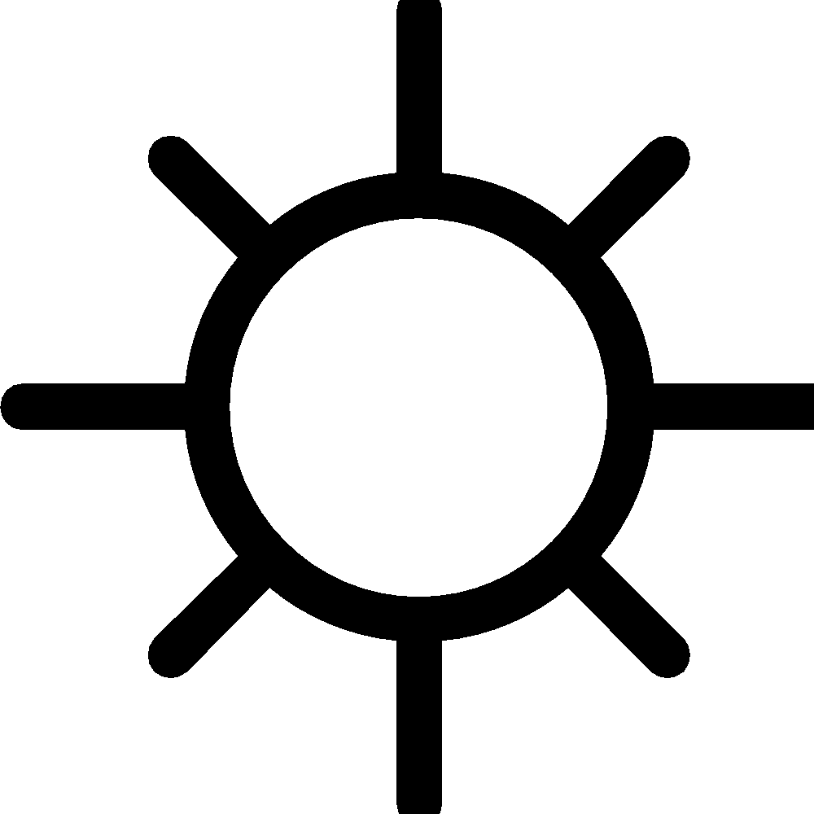 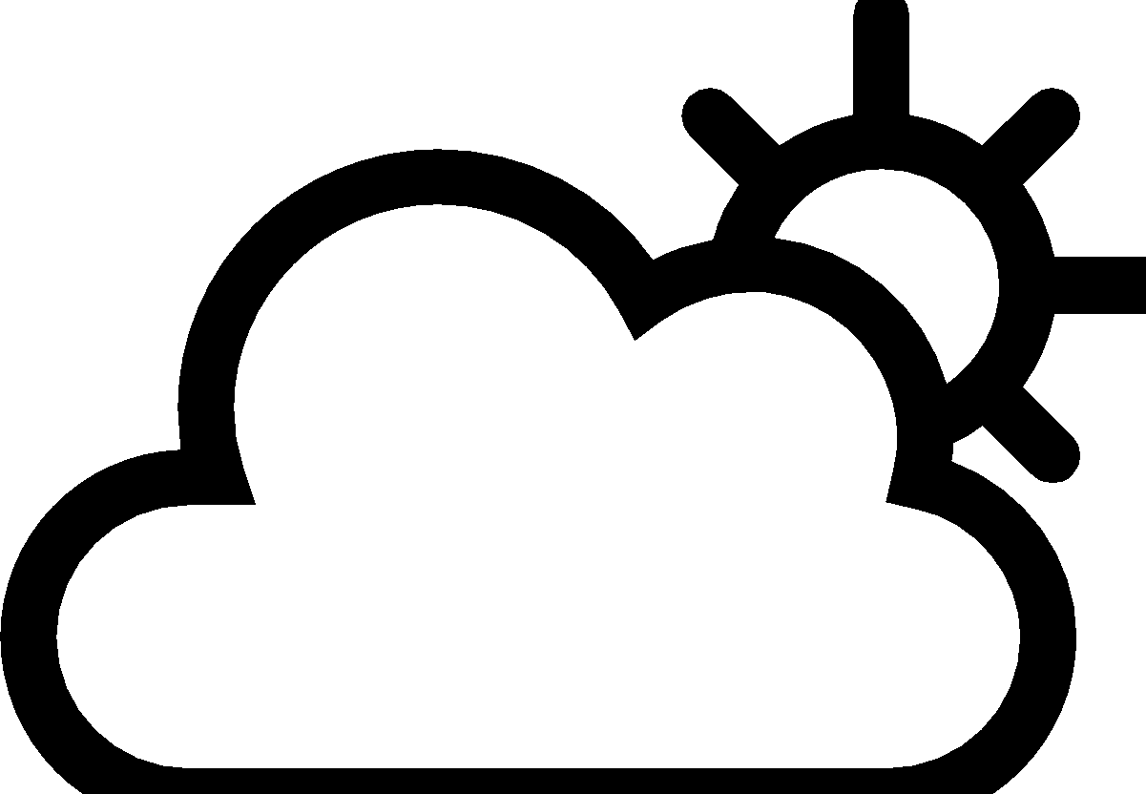  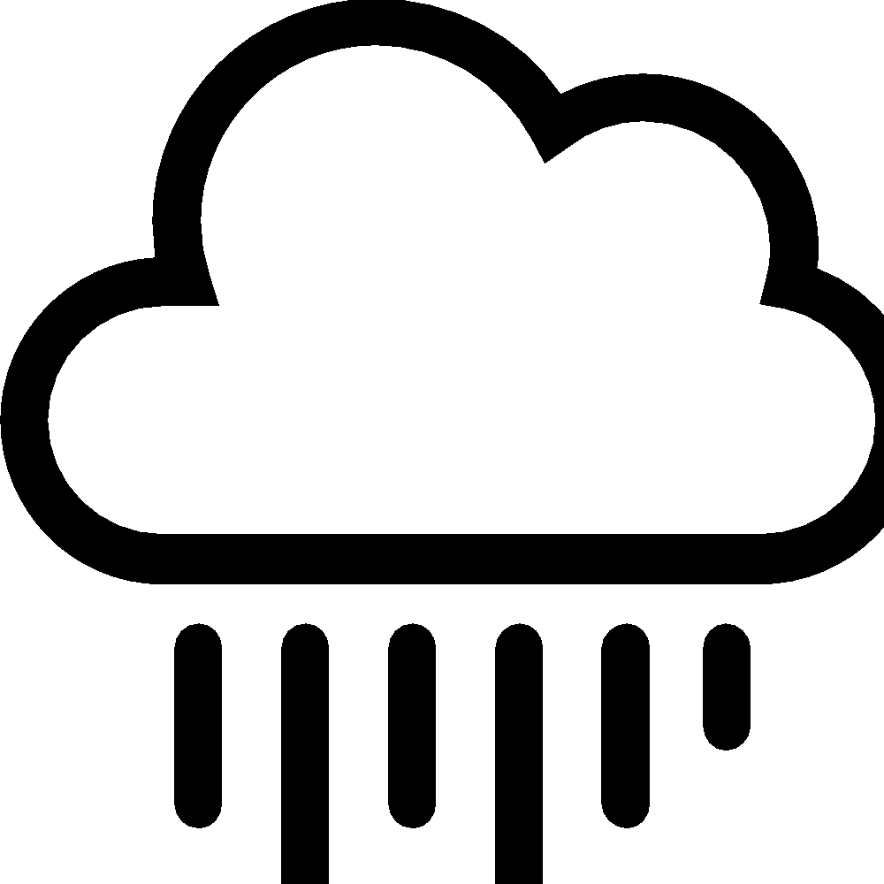 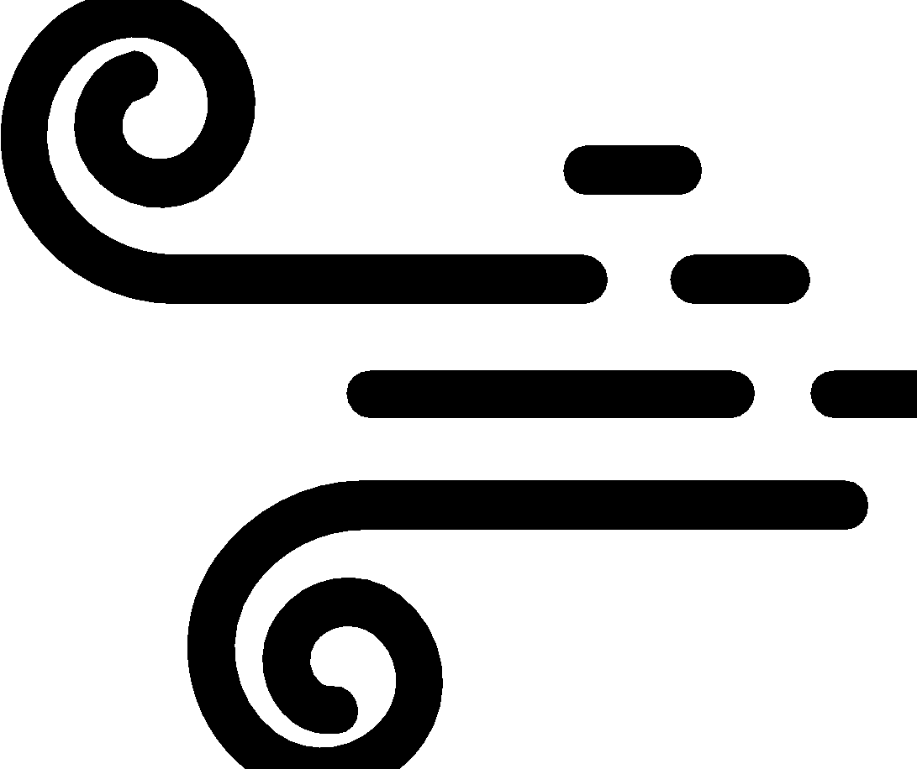 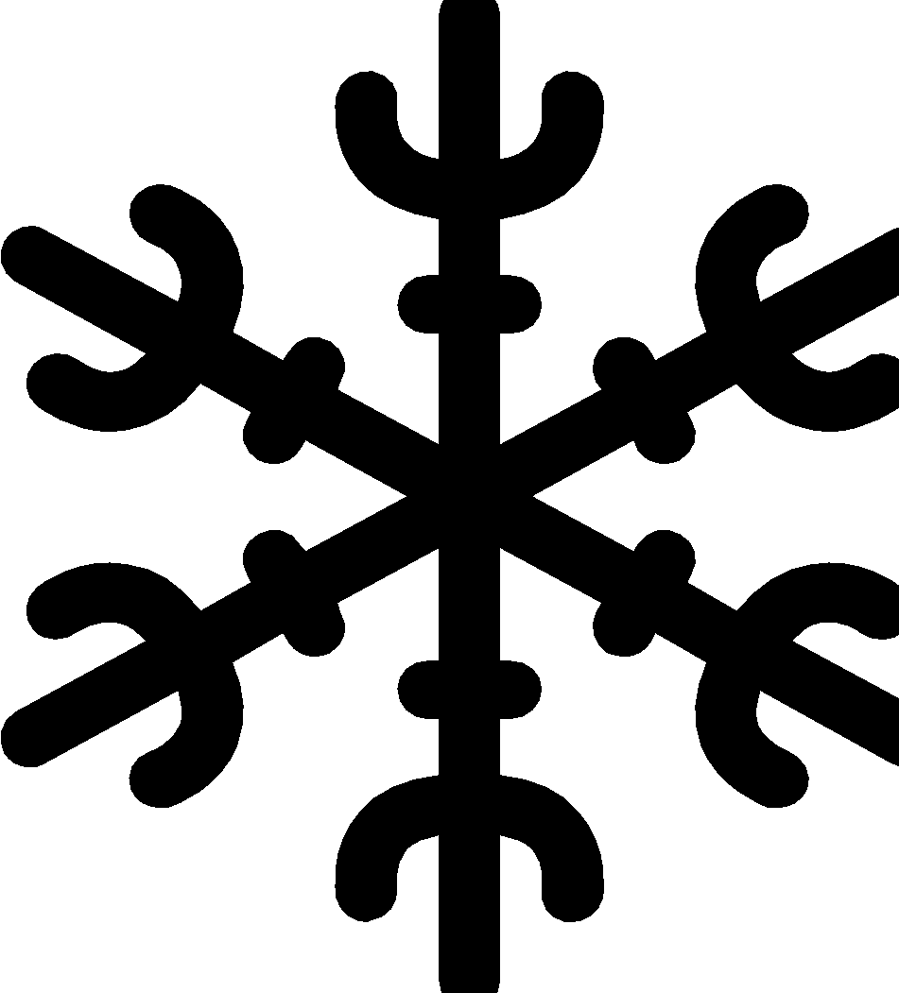 Temperature (hot, warm, cool, cold): _____________
Draw what you observe here, including relationships between animals, plants, weather, soil, etc.

↑above

around
← →

↓ below
We Wonder…

What was something that surprised you on your observation walk?

Has anything changed since the last time you did an observation walk? If so, why do you think this was so?

How do you think the weather and season today influenced what you observed? Do you think anything else influenced what you observed today?

We observed (our phenomenon)____________________________________________________

The season is ___________________
 | Location/Time  Weather: ____________  Temperature: _________ | Location/Time  Weather: ____________  Temperature: _________ | Location/Time  Weather: ____________  Temperature: _________ | What Questions do We Have?
Differences  What is something you noticed that is different about your observations across locations or time? | Something different we noticed was:  _______________________________________________________________  We think it was different because: _______________________________________________________________  _______________________________________________________________  _______________________________________________________________
Similarities  What is something similar that you noticed about your observations across locations or time? | Something similar we noticed was:  _______________________________________________________________  We think it was similar because: _______________________________________________________________  _______________________________________________________________  _______________________________________________________________

